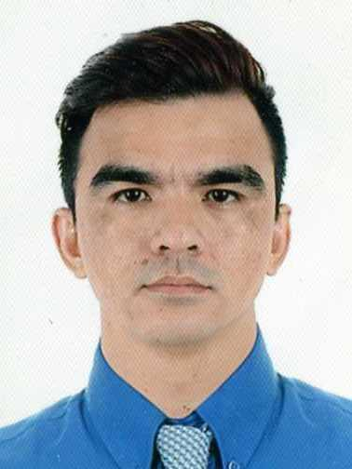
Andong, Ryan del Rosario
#1443 Russel St. Green Meadow PH.2 Mabiga, Mabalacat City, Pampanga 2010
Email: crykentm@gmail.com
Tel: (+63)936-886-6971(Mobile)
OBJECTIVE
To build a long-term career in Call Center/BPO company with opportunities for career growth. To solve problems in a creative and effective manner in a challenging position.
SUMMARY OF QUALIFICATIONS
- A newly qualified individual who's passionate about working in the entry level field and is ready to take on a challenging position to further my career
- Excellent interpersonal, communication and relationship-building skills.
- Listen attentively, communicate persuasively and follow through diligently
- Selling Products and Services using solid arguments to prospective customers
- Knowledgeable in MS Excel
- National Certificate 2 TESDA – Heavy Equipment Operation on Forklift
Issued on: September 20, 2015 Validity: September 19, 2020
- Knowledgeable in SAP warehouse and material management modules
- Certified Engine Powered Forklift Operator
- Achieved perfect attendance award for the year 2013 for being punctual
- Responsible in creating Purchase Requisitions for Spare Parts
- Certified Raw Material Inspector
EXPERIENCE
- SME – Subject Matter Expert - Traffic Analyst
- SME – Subject Matter Expert – Menu Transcription
- POC of our team Turbo Wave 7A under the Leadership of Bill Badilla
- Teammate at Door Dash - Menu Transcriptionist, Ancillary works, Administrator
- Materials Planning, ordering, scheduling and material handling
- Business competence team member for SAP Material and Warehouse management modules
- System Support Specialist (SAP MM and WM Modules)
- Improvement of warehouse operating procedures and Inventory Control
- Moving product in and out of the warehouse and loading and unloading route – physically or with help of forklift or pallet jack
- Just in time system in terms of inventory control without sacrificing safety, quality and delivery
- Provided leadership, instruction and supervision in achieving zero inventory variance
- Maintaining the warehouse using the 5’s
- Proven ability to communicate effectively in diverse environments and able to make difficult decisions in stressful situations
- Oversight of all aspects in customer service performance
- Experienced in crew certification, performance evaluation, progressive discipline and grievance procedures in accordance with the company standards
- Experienced with expertise in human relations in achieving of strategic and company goal
EMPLOYMENT HISTORY
- January 25, 2018 - Present Traffic Analyst/ Menu Transcription - TaskUs
- August 2016 – January 18, 2018 Technical Sales Representative - MOIKAI ISAS
- January 2008 – August 2016 PLANT CONTROL Assistant- Cost & Inventory (Material Planner/ Warehouseman/ Inventory Controller)
-Yokohama Tire Philippines Inc.
- April 2007 – September 2007 Machine Operator Vison Dyna MGS
(Yokohama Tire Philippines Inc.)
- April – September 2006 Stock Clerk/Warehouseman Toy Kingdom (SM Clark)
- October 2004 – March 2005 Factory Worker Clark Plastics (owned by KITA Corp.)
- July – December 2000 Service Crew Shekinah Fried Chicken, Balibago A.C

SEMINARS ATTENDED
- April 20 – 24, 2015 – Standard First Aid & CPR/ AED (first aider)
- January 16 & 17, 2014 – SAP Procurement to Payment process Inventory Management & Warehouse Management
- February 20, 2014 – SAP Material Requirements Planning (MRP)
- December 2-6 2013 – Standard First Aid / Basic Life Support
- July 2013 – Basic Leadership Training
- December 2013 – Revised Risk Assessment System Training
- May 2012 – Effective Presentations Skills Workshop
- October 2011 – 3 C’s on Effective Team Player
- April 13-14 2011 – Warehouse and Operations Management
- April 2011 – BBS Safety Driving
- March 2010 – Just in Time Orientation
- January 2009 – Vision to Win Seminar
- January 2008 – Safety Training & Orientation
- January 2008 – Basic Tire Technology
- July 2008 – Forklift Certification

ACHIEVEMENTS
- Core Value Nominee - TaskUs
- Model Employee Nominee - Yokohama Tire Philippines Inc.
- Five Years (5) Service Awardee - Yokohama Tire Philippines Inc.
- Best in Tire Production System (Improving Warehouse Operating Procedures, Inventory Control and Cost Reduction) - Yokohama Tire Philippines Inc.
- Special Appreciation (Improving Warehouse Operating Procedures, Inventory Control and Cost Reduction) - Yokohama Tire Philippines Inc.
- Perfect Attendance for The Year 2013
Venue: Yokohama Tire Philippines Inc.,

EDUCATIONAL BACKGROUNDS
High School : Mauaque Resettlement High School
School Year : 1999

PERSONAL PARTICULARS & PREFERENCES
Date of Birth : 12 December 1982
Age : 37 years old
Nationality : Filipino
Gender : Male
Marital Status : Married
Height : 5 ft. 7 inch
Weight : 67 kg.

REFERENCES
Name : Irene Manansala
Position : Team Leader
Company : TaskUs House Teamwork

Name : Bill Badilla
Position : Team Leader
Company : TaskUs House Teamwork

I hereby certify that above data are true and correct.
_____________________
Ryan del Rosario Andong

