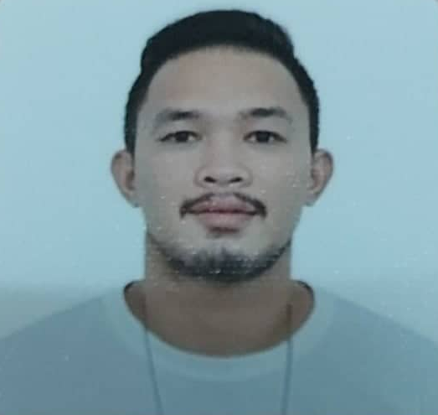
Jovel Isaac M. Lunas
130 Bayan Street, Barangay Bungad, Quezon City, Philippines 1500
09562332678 / 09496349697 / 02 8532-4087
jisaaclunas17@gmail.com

Professional Summary

Experienced Butcher for over 12 years, completes projects with confidence and skill. Performs well under pressure and accomplishes successive assignments accurately. Thrives in a fast-paced environment and adapts well to changing situations.

Skills

- Knowledge of meat cutting and techniques.
- Ability to use knives and other cutting tools.
- Knowledge of food hygiene and safety requirements
- Ability to work well as part of a team.
- Reasonable level of physical strength and stamina.
- Having an eagerness to learn and the desire to do quality work.
- Patient and willing to take time on a job to ensure it is done properly.

Work Experience

Butcher / Slaughterman 2005 - Present
Labudahon Abattoir
Quezon City, Philippines
- Ensuring work areas are clean and compliant with all food safety and hygiene standards.
- Preparing personal protective equipment/ materials to slaughtering activities.
- Unloading animals carefully to avoid stress and injuries.
- Animals are rested and off feed before slaughtering.
- Washing the animals prior to slaughter.
- Stun animals prior to slaughtering.
- Performing animal slaughtering and butchering.
- Slit open, eviscerate, and trim carcasses of slaughtered animals.
- Shackle hind legs of animals to raise them for slaughtering or skinning.
- Cut, trim, skin, sort, and wash viscera of slaughtered animals to separate edible portions from offal.
- Breaking down carcasses into primary and secondary cuts.
- Processing meat using knives, cleavers, saws and other equipment.
- Preparing and Cutting meat in accordance with laid down procedures.
- Negotiating and confirming orders with suppliers.
- Coordinating deliveries and order pickups.
- Adhering to food safety & sanitation controls.
Checker 2013 - 2020
Marshall Poultry Farm
Sta. Maria Bulacan, Philippines
- Checking the quality and weighing the hogs/swine.
Education and Training

Information Technology May 2009
Eastern Institute of Computer Technology, Quezon City, Philippines

National Certificate II in Slaughtering Operations December 2011
Technical Education and Skills Development Authority

