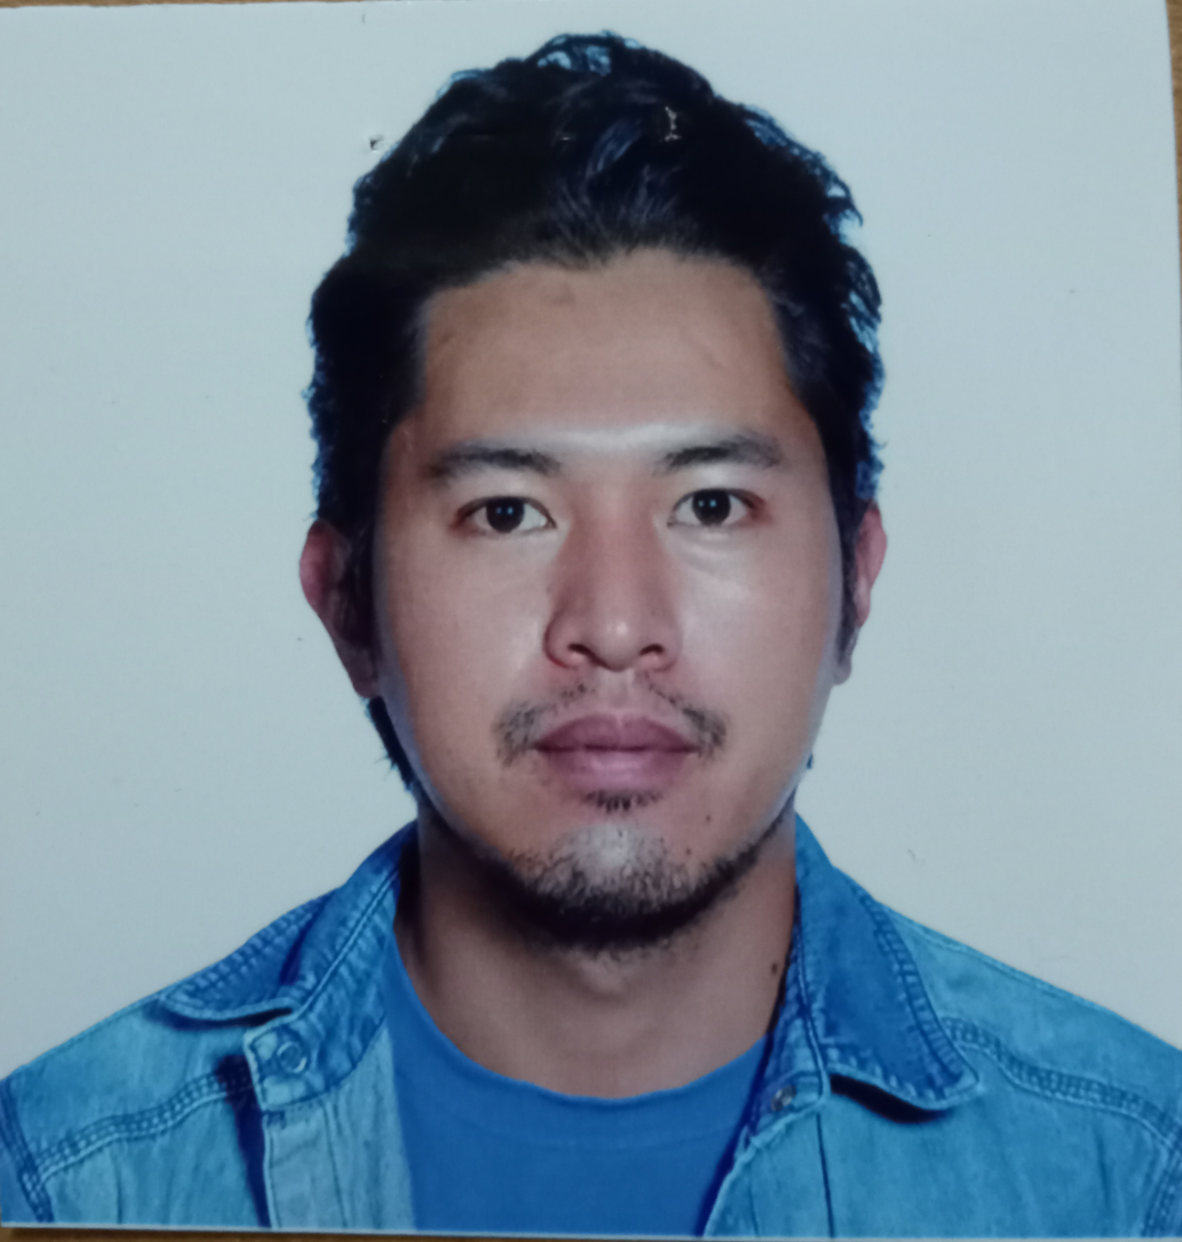
Anthony Tenda Phone: +639214510272
122 Purok 7 Sunny Side Fairview Baguio City E-mail: anthonytenda21@yahoo.com

CAREER OBJECTIVE
Seeking a full-time position as Cook / Butcher/Meat cutter where I can further my knowledge and experience in the hospitality industry.

CORE STRENGTH
I have over eight (8) years of experiences in varied fields of hospitality which honed my skills in customer service, butchery, cooking, food preparation, portioning/Preparation cook and overall kitchen helper.

WORK EXPERIENCE

Assistant Cook/Butcher/Meat Cutter La Trinidad Benguet
Kaleis Grill Restaurant 02/2019-09/2021
Pine Valley Plaza, JB-012, KM.4

- Cooked and prepare for over 120 people daily
- Established rapport and build relationship with customer which made them regular patrons.
- Ensure meat are cut and prepared in a timely manner.
- Works successfully with Owner and co worker to meet daily customer needs and manual profit target.

Crew Member ( Commis De Cuisine) 8 Months on Board
Costa Favolosa International Cruise Ship Magsaysay Maritime Corporation, T.M. Kalaw St. Ermita Manila 05/2018-01/2019

- Assisted the Chef in preparing food for the 3,000 crew members.
- Work closely with team to fulfill the task at hand in a timely manner.
- Built strong customer relationship with crew
- Prepared menu for the crew
- Fulfilled contract successfully

Preparation Cook and Portioning La Trinidad Benguet
Kaleis Grill Restaurant 10/2015-04/2018
Pine Valley Plaza, JB-012, KM.4

- Cooked for over 120 people daily

Preparation Cook
Mother’s Garden Panorama Café and Restaurant Baguio. City
Upper Fairview 07/2014-08/2015

- Cooked for over 100 people daily.
- Worked closely with the Chef and Owner to meet customer needs.

Kitchen Helper
Race Food Company Incorporated Baguio City
Texas Instruments 03/2013-05/2014
EPSA Loakan,

EDUCATION

Colegio De San Juan De Letran Manila, Philippines
Bachelor of Science in Hospitality Management

CERTIFICATES AND TRAININGS

NATIONAL CERTIFICATE II SLAUGHTERING OPERATION (SWINE). TESDA Baguio City
- NATIONAL CERTIFICATE ll (THEORETICAL DRIVING COURSE) TESDA Baguio City
- TESDA National Certificate III (Ships’ Catering and Ship’s Cooks Manila, Philippines
- Certificate of Completion in Hotel Practical Training (F&B Department) Net World Hotel Pasay City, Philippines
- Certificate of Completion in Restaurant Practical Training Aristocrat Restaurant Malate, Manila Philippines
- Butchery/meat cutting Quezon City, Philippines

TECHNICAL SKILLS

MS Word, Excel, PowerPoint
Anthony Tenda Phone: +639214510272
122 Purok 7 Sunny Side Fairview Baguio City E-mail: anthonytenda21@yahoo.com

REFERENCES

- Carmela T. Obo-ob
Title: General Manager and Owner
Company: Kaleis Grill Restaurant
Address: Pine Valley Plaza, JB -012, KM. 4 La Trinidad Benguet
Mobile Number: +639987928928
Years known: Over 6 Years

- Nebu Medel
Title: Chef De Partie
Company: Costa Cruise Line
Address: 520 T.M Kalaw Street, Ermita Manila Philippines
Title: Chef Tournant
Company: Norwegian Cruise Line
Address: 290-292 Casa Rocha Building General Luna Street Intramuros Manila, Philippines
Email: nebumedel164@gmail.com
Phone:09184908781

- Maria Luisa Carlos
Title: Program Chairperson
Company: Information Technology Colegio De San Juan De Letran
Company: Colegio De San Juan De Letran
Phone: 09177950593
Email: marialuisa.carlos@letran.edu.ph
Relationship: Former Professor
Years Known: Over 4 Years

