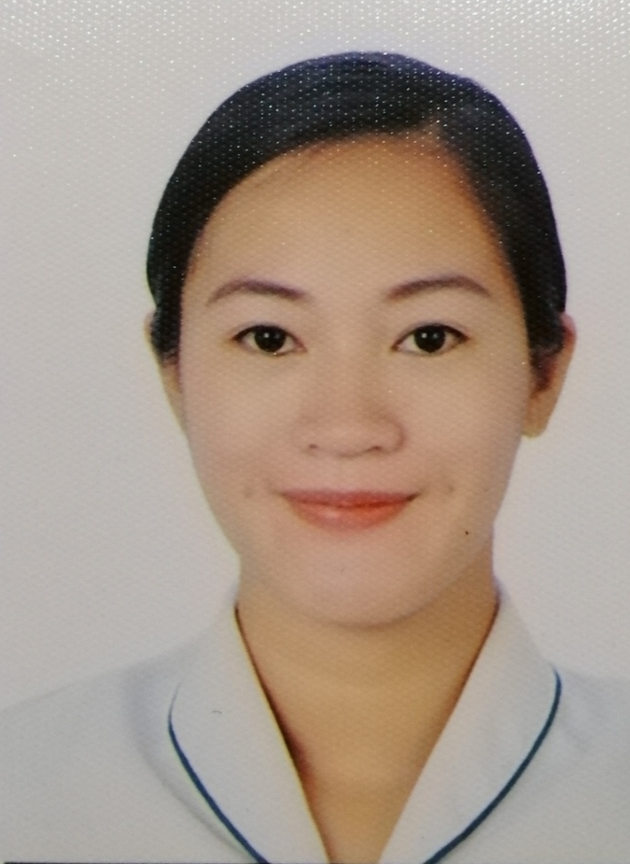
Name: Charice Mae Balcanao
Address: Bulanao, Tabuk City, Kalinga, Philippines
Contact Number: 09150285023
Email: cayrelcha@gmail.com

PERSONAL INFORMATION
Date of Birth November 2, 1993
Place of Birth Tabuk City, Kalinga, Philippines
Citizenship Filipino
Civil Status Single
Religion Roman Catholic

EDUCATIONAL BACKGROUND
Tertiary
June 2017-September 2021 Bachelor of Science in Nursing
University of the Cordilleras
Gov. Pak Road, Baguio City
Secondary
June 2005-April 2008 Tabuk National High School
Tabuk City, Kalinga

June 2008-May 2009 Conner Central National High School
Conner, Apayao

Licensure Examination Took and passed Nursing Licensure Examination
November 21-22, 2021 Baguio City Central School
Baguio City

SEMINARS, TRAININGS AND WORKSHOPS ATTENDED
"Basic Life Support and Advanced Cardiac Life Support"
February 21-22, 2022
Heart Up Training Center
Sampaloc, Metro Manila
“Filipino Nurses’ Call for R.E.S.E.T.: Landscape for Future
Health Care (Responsive, Education driven, Service redesign, Envisioning,
Transformation).”
December 20 & 21, 2021
Webinar- Participant
Bleeding Dilemmas in Children: “The Bleeding
Gut in Pediatrics. Latest Trends in Diagnosis and Management” and
“Assessment and Management of Bleeding Disorders in PICU”
December 15, 2021
Webinar - Participant
“Integrated Management of Childhood Illness Seminar & Training”
2018
University of the Cordilleras-Participant

"HIV Updates, Emotional Intelligence, Alternative Health Care, and National Immunization Program"
May 4, 2018
University of the Cordilleras - Participant
Baguio City

SKILLS
-Languages and dialect: Kalinga, Ilocano, Tagalog, English
-Strong interpersonal skill
-Technical, creative and good English communication skills
-Multicultural-oriented

