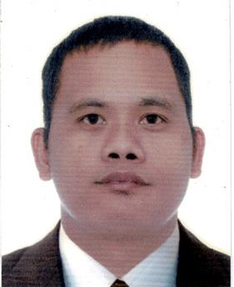
GILBERT GONZALES SIGNO
Area J Block18 Lot 20 Reuben St., Brgy. Delas Alas,
General Mariano Alvarez Cavite 4117
Cell No.# 09358173403
Email Address: Gibe007@yahoo.com

JOB DESCRIPTION: Smaw Welder, Mezzanine, Column, I-beam and Fabrication.

WORK HISTORY

Company: Marksteel Group of Company
Address: Carmona, Cavite
From: Feb. 2022 to present
Position: Welder / Mezzanine, Column, I-beam, Railings.

Company: JRCD SUBIC TRANSPORT
Address: Barangka, Mandaluyong City
From: Feb. 2016 to January 2019
Position: Airport Taxi Driver
Company: Twist and Turn Metal Craft
From: June 2010 to May 2012
Address: Mabuhay, Carmona, Cavite
Position: Welder Fabricator Gates, Fence, etc.

Company: Utsuta Metal Stamping Phils. Inc.
Address: Sto. Tomas, Binan, Laguna
From: Sept. 2007 to March2008
Position : Production Operator.

PERSONAL INFORMATION

Age: 39 yrs. old
Height: 5’7”
Weight: 83.80 kgs
Status: Married
Religion: Roman Catholic

EDUCATIONAL ATTAINMENT

College: National College of Science & Technology
Address: Aguinaldo Highway Dasmarinas Cavite.
Course: Police Science
From June 1999 to March 2001.

High School: Gen Mariano Alvarez Technical High School
Address: Gen Mariano Alvarez Cavite
From June 1995 to March 1999.

Elementary: Arejes Elementary School
Address: Brgy Lumbreras GMA Cavite
From June 1989 to 1995

CERTIFICATES

Training Certificate and Govt I’D
Passport # P7247559B From July 22, 2001 to July 21, 2031

Tesda NC2 Shielded Metal Arc Welding
Certification No. 17042102001244
From Feb 14 2017 to Feb 14 2022

Tesda NC1 shielded metal arc welding
Certification No. 10040301011430
From Nov. 2010 to Nov. 2015

I hereby certify that the above information is true and correct to the best of my knowledge and belief.

GILBERT GONZALES SIGNO
Applicant

