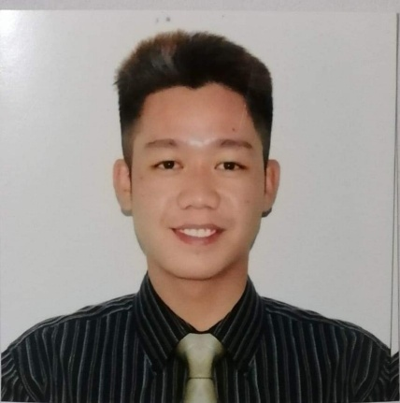
VILLANUEVA,KENNETH CAJUCOM
Purok 4 brgy. Bucot Aliaga Nueva Ecija
0936-270-5711
kvillanueva257@gmail.com

OBJECTIVE

To be able to work in a career oriented and challenging environment that promotes personal growth and uplifts professional development as well as to help utilize my skills and knowledge.

EDUCATIONAL ATTAINMENT

VOCATIONAL COURSES

FORKLIFT APRIL 2021 Nadora Training Center
Bibiclat, Aliaga Nueva Ecija

BACKHOE LOADER NCll MARCH 2021 Nadora Training Center
Bibiclat, Aliaga Nueva Ecija

HAIR DRESSING NCll NOVEMBER 2019 PMTC
Cabanatuan City,Nueva Ecija

SECONDARY 2011-2015 Aliaga National High School Aliaga,Nueva Ecija

PRIMARY 2004-2010 Bucot Elementary School
Bucot,Aliaga,Nueva Ecija

WORKING EXPERIENCE

TECHNICIAN
SJ CELLPHONE REPAIR AND ACCESSORIES
Poblacion West III, Aliaga,Nueva Ecija
2019-2021

TECHNICIAN/PROGRAMER
DB SCHENKER
Pasig City
2018

FORKLIFT OPERATOR
DB SCHENKER
Pasig City
2018-2019

FORKLIFT OPERATOR
Liberty Flour Mills inc.
Mandaluyong City
2021-2022

SKILLS SUMMARY
- Knows how to speak in Filipino and English
- Proficient with using MS Office, MS Excel, MS Powerpoint
- Ability to multi-task, manage priorities in a fast-paced environment

PERSONAL INFORMATION

Date of birth: November 22,1997
Place of birth: Cabanatuan City
Age: 24 yrs old
Height: 5’8
Weight: 65 kls
Gender: Male
Civil status: Single
Nationality: Filipino
Language: Tagalog and English
Religion: Roman Catholic
Father’s Name: Crisilito Villanueva
Mother’s Name: Adoracion Villanueva

CHARACTER REFERENCES

Mr. Joshua Danao
Instructor
TESDA
09484276451

Mr. Jeffrey Samson
Surveyor, Marketing Department
AlphaRed Management System Incorporated
09279785740

I hereby certify that the above information is true and correct to the best of my knowledge and beliefs.

VILLANUEVA, KENNETH CAJUCOM
Applicant’s Signature

