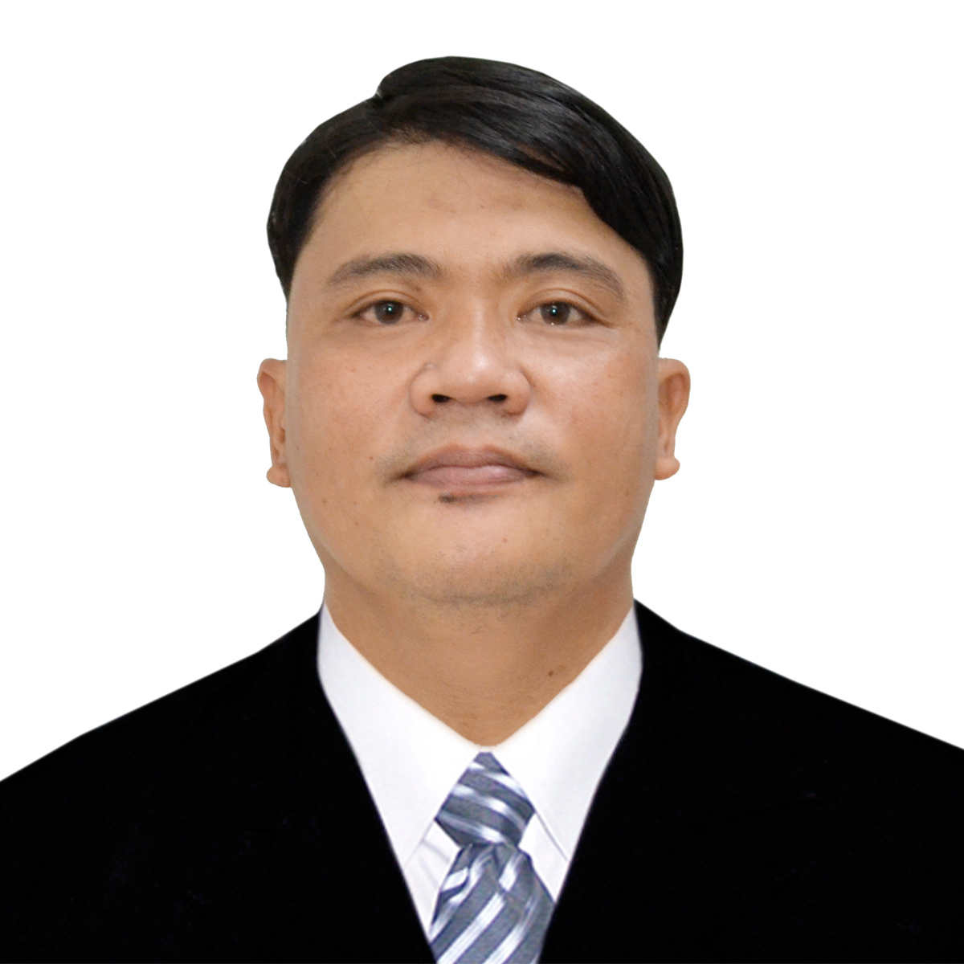
Curriculum Vitae

Victor M. Ventura
Brgy.16 #21 Rizal Blvd. Bacarra Ilocos Norte Philippines
Contact No: 09608662433
Email: victormateventura62884@gmail.com

PROFESSIONAL SKILLS
- Former Owner and Manager of Ventura Construction Services
- Former Data Researcher at Avion BPO Corporation
- Former Area Supervisor at Department of Social Welfare and Development (Listahan Household Assessment.)
- PC-troubleshooting (Hardware)
- Driver of 10 wheels 6 wheels 4 wheels and 2 wheels with Philippine Professional Driver’s License Restriction 1,2,3
- Exceptionally good in interpersonal and communication skills
- Can troubleshoot 2 wheel, 4 wheel and 6-wheel engine
- Contractor of Buildings
- Can read and understand architectural and structural plan
- Well knowledgeable in welding, plumbing and electrical
- Foreman civil
- Site Supervisor
- Trained Standard First Aider CPR/AED
- Well Knowledgeable in reading and interpreting architectural and structural plans
- Trained Safety Officer
- Philipphine Passport holder

EDUCATIONAL BACKGROUND
Tertiary: Divine Word College of Laoag Undergraduate
Bachelor of Science in Infornation Technology
Brgy. 13 Gen. Segundo Ave. Laoag, Ilocos Norte
Graduate of Theology
Faith Bible Institute 2005 - 2010
Secondary: Divine Word College of Laoag 1997 - 2001
Brgy. 13 Gen. Segundo Ave. Laoag, Ilocos Norte
Elementary: Tuguegarao East Central School 1992 – 1997

PERSONAL INFORMATION
Married, Born on June 28, 1984 – Brgy. Umboy Wawa Sta. Cruz Laguna, Filipino Citizenship, Baptist. Good command communication skills both in oral & written (English & Filipino). Able to learn quickly, demonstrate flexibility and persistence. Dependable, analytical and hardworking; Can work well both independently and as a team.

EXPERIENCES
Driver and personal encoder Revenue District Officer of Bureau of Internal Revenue
Laoag City Philippines from 2010 up to year 2013.
Data Researcher in Avion BPO Corporation from September 30, 2014 up to April 15, 2015
Civil Foreman at Ambassador Baptist Church Inc. from January 2016 up to December 2019.
Former Area Supervisor at Department of Welfare and Social Development
Foreman Civil at EEI Corporation Skyway Stage 3 Project (Balintawak to NLEX Section) February 2020 to November 2020.
Sub-Capataz at Acciona-DMCI Laguna Lake Consortium 150 MLD Laguna Lake Water Treatment Plan Project February 2021 to September 2021
Currently Lineman Foreman at Meralco Industrial Engineering Services Corporation.
Former Pastor at Ambassador Baptist Church from January, 1, 2005 to December,30,2019

I hereby certify that the above information is true and correct to the best of my knowledge and belief.

Victor Mateo Ventura

