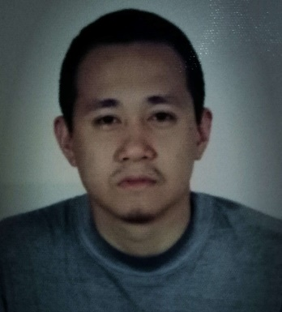
HILLARY MANABA PEPITO
Address: Lot13, Blk2, Rajah Townhomes Basak, Mandaue City, Cebu Philippines
Mobile Number: +639501540718
Email: ugag081003@yahoo.com
Nationality: Filipino
Date of Birth: April 6, 1984

OBJECTIVE: To be part of a company in which I could impart my skills and contribute to its growth and development, to achieve the company and customer satisfaction and in return I could eventually achieve personal and professional progress.

EDUCATION

Elementary: Consolacion Central School 1991-1997
High School: Saint Louis School of Mandaue 1997-2001

WORK EXPERIENCE

HPJ Plumbing Services
March 15, 2021 up to the present
Position: Plumber
Responsibilities:
- Install, repair, and maintain pipes, valves, fittings, drainage systems, and fixtures in commercial and residential structures
- Respond to diagnose and resolve plumbing emergencies

- Magsaysay Maritime Corporation (COSTA CRUISE LINES Int’l)
July 2012 - November 2017

Position: Plumber / Technician in Cruise Ship (Seaman/OFW)

Responsibilities:
- Checking and repair motor pumps for sewage plants, [EVAC & JETS vacuum system, treatment plant and relevant tank. (black water and gray water)
- Repair and Maintenance of all Galley machinery and equipment’s
- Repair and Maintenance of Public and Passengers cabins toilet, hot and cold water, showers, spa rooms and laundry.
- Installing and repairing all types of water piping’s in the ship, laundry machineries
- Checking and repairing swimming pool plants, valves, pipes and expansion tanks.
- Piping & installation valves, pumps and drainage system
- Repair and maintenance services of piping connection
- Maintenance service of pumps and repair of plumbing fixture
- Can do paper works and computer for reports.

- BSLG Constructions
October 21, 2008 – December 5, 2010

Position: Plumber

Responsibilities:

- Assemble, install, maintain, and pressure test all pipes, fittings, and fixtures of heating, water, drainage
- Determine sources of plumbing malfunctions and complete repairs as indicated or according to work orders
- METS General Services

February 24, 2006 - March 31, 2008

Position: Plumber

Responsibilities:

- Installs, repairs and maintains domestic, commercial, and industrial plumbing fixtures and systems;
- Locates and marks positions for pipe connections, passage holes, and fixtures in walls and floors;
- Measures, cuts, bends, and threads pipes using hand and power tools or machines

