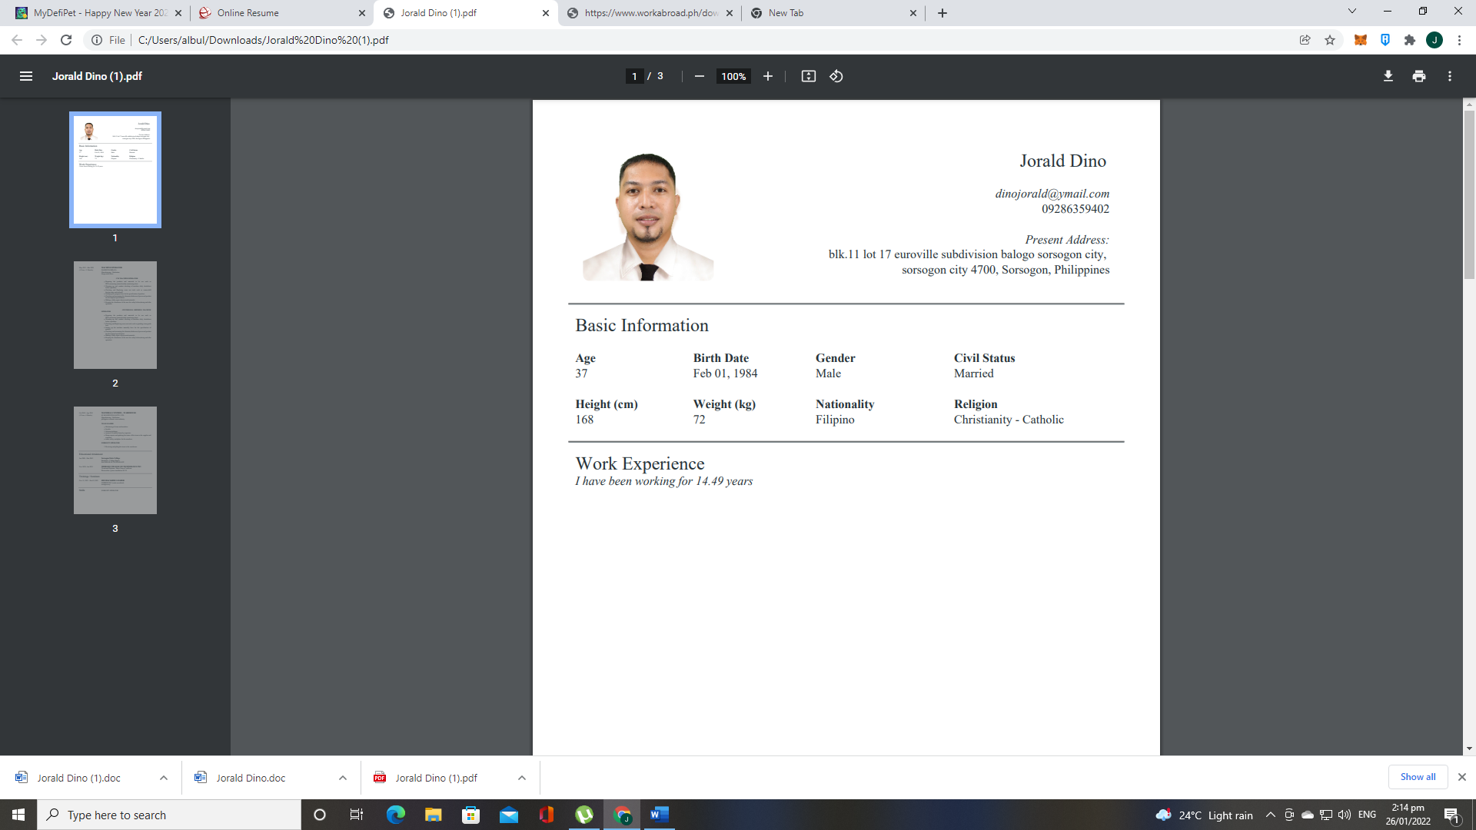 | Jorald Dino  dinojorald@ymail.com  09286359402  Present Address:  Blk.11 Lot 17 Euroville Subdivision Balogo Sorsogon , Sorsogon city 4700, Sorsogon, Philippines

Basic Information
Age  38 | Birth Date  Feb 01, 1984 | Gender  Male | Civil Status  Married
Height (cm)  168 | Weight (kg)  72 | Nationality  Filipino | Religion  Christianity - Catholic

Work Experience
I have been working for 14.49 years
May 2015 - Mar 2020  (4 Years, 11 Months) | MACHINE OPERATOR  DAERIJUNGMIL(JU)  Manufacturing / Production  Daegu, South Korea  CNC MACHINE OPERATOR  Duties and Responsibilities:  - Preparing the products and materials to be use such as PPE's, measuring materials, daily monitoring sheet.  - Warming up and conduct checking of machine daily checksheet before operation.  - Checking and Replacing worn out tools such as reamer, drill bits, tip, cutter and end mill.  - Setting up the program base for the specification of product.  - Checking and measuring the diameter, thickness of processed product for the required specification.  - Making a daily report of processed materials.  - Keeping the cleanliness of the area for safety before, during and after operation.  CENTERLESS GRINDING MACHINE OPERATOR  Duties and Responsibilities:  - Preparing the products and materials to be use such as PPE's, measuring materials, daily monitoring sheet.  - Warming up and conduct checking of machine daily checksheet before operation.  - Checking and Replacing worn out tools such as grinding stone, guide bars.  - Setting up the machine manually base for the specification of product.  - Checking and measuring the diameter, thickness of processed product for the required specification.  - Making a daily report of processed materials.  - Keeping the cleanliness of the area for safety before, during and after operation.
Oct 2005 - Apr 2015  (9 Years, 6 Months) | MATERIAL CONTROL - WAREHOUSE  SCAD SERVICES (S) PTE. LTD..  Manufacturing / Production  Philippine Economic Zone Authority  TEAM LEADER  Duties and Responsibilities:  - Monitoring of items and members.  - Encoder  - Ordering in charge.  - Issuance of ordered items by requestor.  - Doing reports and updating the status of the items to the supplier and requestor.  - Ensure safety workplace for the members.  FORKLIFT OPERATOR  Duties and Responsibilities:  - Receiving and piling of items to warehouse.

Educational Attainment
Jun 2000 - Mar 2002 | Sorsogon State College  Bachelor's / College Degree  BACHELOR OF TECHNOLOGY
Nov 2020 - Jan 2021 | MERIAM COLLEGE OF TECHNOLOGY INC.  Vocational Diploma / Short Course Certificate  Photovoltaic system installation NC-II

Trainings / Seminars
Nov 15, 2021 - Dec 02, 2021 | HEO BACKHOE LOADER  SORBEEP INC. (Tesda Accredited)  Sorsogon city

