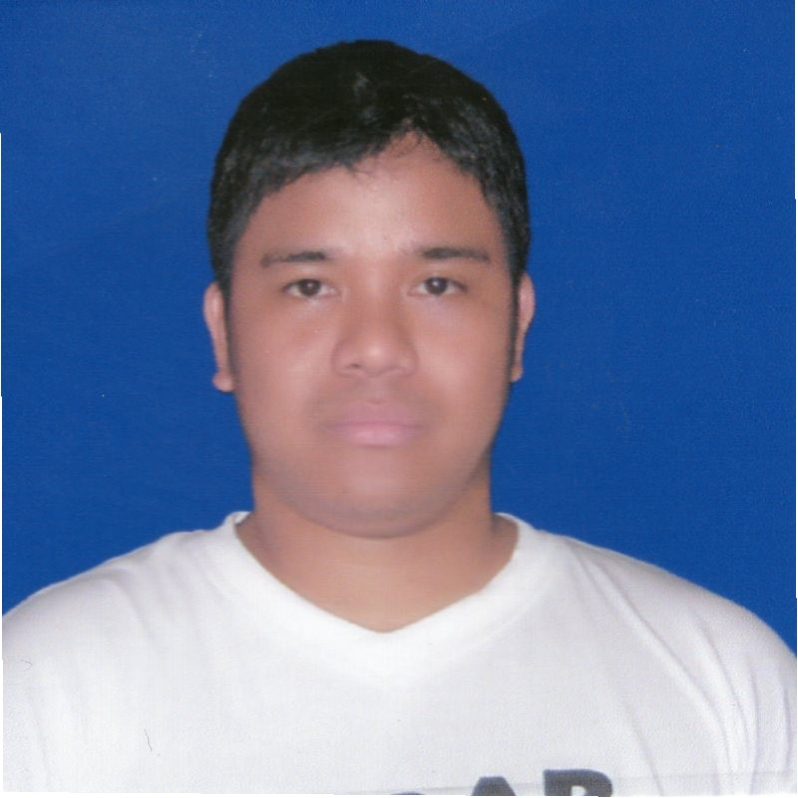
LEANARD M.QUIAMNO
Blue Isle Phase 3-B Block 12 Lot 11
Sta. Maria Sto. Tomas Batangas
Philippines
Contact no. 09096818632
Email Add: quiamgina@gmail.com

CAREER OBJECTIVES:
To secure a position with stable and profitable organization, where I can be a member to utilize business expertise to the fullest.

PERSONAL INFORMATION

Date of birth | August 13,1981
Place of birth | Batang Ligao City
Civil Status | Married
Citizenship: | Filipino
Weight: | 75 kgs
Height: | 5’7
Religion: | Roman Catholic
Fathers Name: | Francisco Quiamno
Mothers Name | Teresa Quiamno
Name of spouse: Gina F.Quiamno Language and dialect Tagalog ,English ,Bicol and Arabic

EDUCATIONAL ATTAINMENT
VOCATIONAL
Course: Machine Tool and Technology
School Year: 1998-1999
School: Technical Education and Skills Development Authority (TESDA)
East Service Road Taguig City Metro Manila

SECONDARY
Ligao National High School
School year: 1994-1998

PRIMRY
Batang Ligao Elementary School
School Year: 1988-1994

WORK EXPERIENCES

October 1999- September 2006
VL Industech Corporation
Maremill Subdivision Landayan San Pedro Laguna
Position: Machinist

February 2007- September 2008
Fedco Paper Corporation
Carmelray Industrial Park 1, Canlubang Calamba City Laguna
Position: Machinist

September 2008- January 2011
Advance Hydraulic System
K.S.A P.O. Box 45659 Riyadh Saudi Arabia
Position: Machinist

April2011–May2012
Union Galvasteel Corporation
Brgy. Real Clamba City, Laguna
Position: Machinist
July 2012-July 2017
Adtech Metal Precision
Hilon Compound, Mayapa Clamba City, Laguna
Position: Machinist
February 2018- July 2020
New Sun Machine Shop
San Pioquinto Malvar Batangas Position: All around Machinist
April 2021 up to present. DJEMS Accumetal Services San Miguel Sto. Tomas Batangas Position : Machinist

JOB DESCRIPTION
•Fabricating all kinds of gears such as Helical, Spar, Worm, Bevil and Splined Gear
•Fabricating forming balancing die and cutter
•Fabrication and istallation of forming machine
•Fabrication in machine re conditioning
•Operates coventional lathe machine, milling, surface grinder, shape and drill press, radial machine and other equipment basically used in metal fabrication.
•Fabricate various toolings, diecasting, molds, jigs and fixtures according to drawing and its given dimensions.
•Check and repair malfunction machine and equipment replace gear and bearings
•Performing other duties as may assigned by the machineshop manager.
•Competent in using instuments like Dial Indicators, Micrometrs, Height gauges inside micrometer.
•Studies blueprints, manual drawing, specification or sample parts to derminine dimensions and tolerance of finished work piece, sequence of operations and set-up requirements.

Character References:
Cristobal Quiamno
Project Engineer
Batang Ligao City
Mobile No. 09189218914
Norman Bilog
Line Leader
Adtech Metal Precision
Mobile No. 09093039832
Arnel Paras
President
Adtech Metal Precision
Mobile No. 09228750615
I here by certify that the above mention is true and correct to the best of my knowledge and beliefs.
LEANARD M. QUIAMNO
Signature

