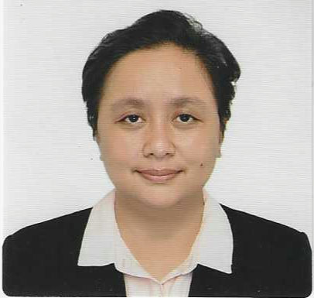
Dr. Lorelei S. Lapan, MD
Fellow, Philippine College of Physicians
Internal Medicine
Lee Gardens Condominium
Lee Street corner Shaw Blvd, Mandaluyong City Philippines
Cell: +639175075758 Email: ieves.jaemie@gmail.com

Summary of Qualifications

- Board Passer, Specialty Board of Internal Medicine, Philippines
- Board Passer, Physician Licensure of the Philippines
- Basic Life Support, AHA
- ACLS, AHA
- Animal Bite Full Course Training

Professional Experience

Medical Specialist I, Internal Medicine March 26, 2022 – Present
National Center for Mental Health, Nueve de Pebrero, Brgy Mauway Mandaluyong City Philippines

Responsibilities

- Daily rounds
  - Female Medical Infirmary (FMI), Medical Extensions
  - Intensive Care Unit (ICU)
  - Patient Referrals from other departments/medical pavilions
  - Clearances of Employees that are about to report back to work
  - With privilege to admit Private Patients
- Patient Assessment and Management (during office hours)
  - Patient History
  - Physical Examination
  - Progress Monitoring
  - Laboratory Recommendation, Request and Results Interpretation for working diagnosis
  - Medication Prescription for acute illnesses
  - Maintenance Medication Prescription for chronic illnesses
  - Patient Release to recommending department/pavilion
  - Patient Discharge
- Patient Referral for Subspecialist Evaluation and Specialty Department Management
- Essential Minimally Invasive Procedures
  - Intubation
  - Thoracentesis
Paracentesis

Medical Officer IV, Internal Medicine Hospitalist from December 2018 – March 2022
National Center for Mental Health, Nueve de Pebrero, Brgy Mauway Mandaluyong City Philippines

Responsibilities
- Daily rounds
  - Female Medical Infirmary (FMI)
  - Intensive Care Unit (ICU)
  - Patient Referrals from other departments/medical pavilions
- Patient Assessment and Management (during office hours)
  - Patient History
  - Physical Examination
  - Progress Monitoring
  - Laboratory Recommendation, Request and Results Interpretation for working diagnosis
  - Medication Prescription for acute illnesses
  - Maintenance Medication Prescription for chronic illnesses
  - Patient Release to recommending department/pavilion
  - Patient Discharge
- Patient Referral for Subspecialist Evaluation and Specialty Department Management
- Essential Minimally Invasive Procedures
  - Intubation
  - Thoracentesis
  - Paracentesis

Medical Specialist I, Internal Medicine Hospitalist from July 2018 – December 2018
Mandaluyong City Medical Center 605 Boni Avenue, Mandaluyong City Philippines

Responsibilities
- Non-urgent and Out-Patient Assessment and Management (during office hours)
  - Patient History
  - Physical Examination
  - Laboratory Recommendation, Request and Results Interpretation for working diagnosis
  - Medication Prescription for acute illnesses
  - Maintenance Medication Prescription for chronic illnesses

- Patient Referral
  - From the Out-Patient Department to the Emergency Department for further assessment and management
  - For additional Laboratory Exams
  - For Subspecialist Evaluation and Specialty Department Management
(Out-Patients and Admitted Patients)
  - For additional urgent medication

- Daily rounds (Admitted Patients)
  - Regular Ward
  - Intensive Care Unit (ICU)
  - Patient Referrals from other departments/medical pavilions

- Admitted Patient Assessment and Management
  - Progress Monitoring
  - Patient Discharge

- Essential Minimally Invasive Procedures
  - Intubation
  - Thoracentesis
  - Paracentesis

Chief Resident, Internal Medicine 2015 - 2016
Residency 2013 - 2016
Victor R Potenciano Medical Center (VRPMC) Mandaluyong City, Philippines

Responsibilities
- Administrative
  - Supervision of 1st and 2nd Year Medical Students, under supervision of Training Officer
  - Resident Conference Scheduling
  - Coordination between Hospital Administration and Training Committee for Philippine College of Physician-organized and -approved Residency Training

Education

Doctor of Medicine (June 2005 – May 2009), License No. 0119670
Our Lady of Fatima University College of Medicine

Bachelor of Science in Psychology (June 2001-April 2005)
Pamantasan ng Lungsod ng Maynila (University of the City of Manila)

