JOHN IRVIN B PADI
johnirvinpadi@gmail.com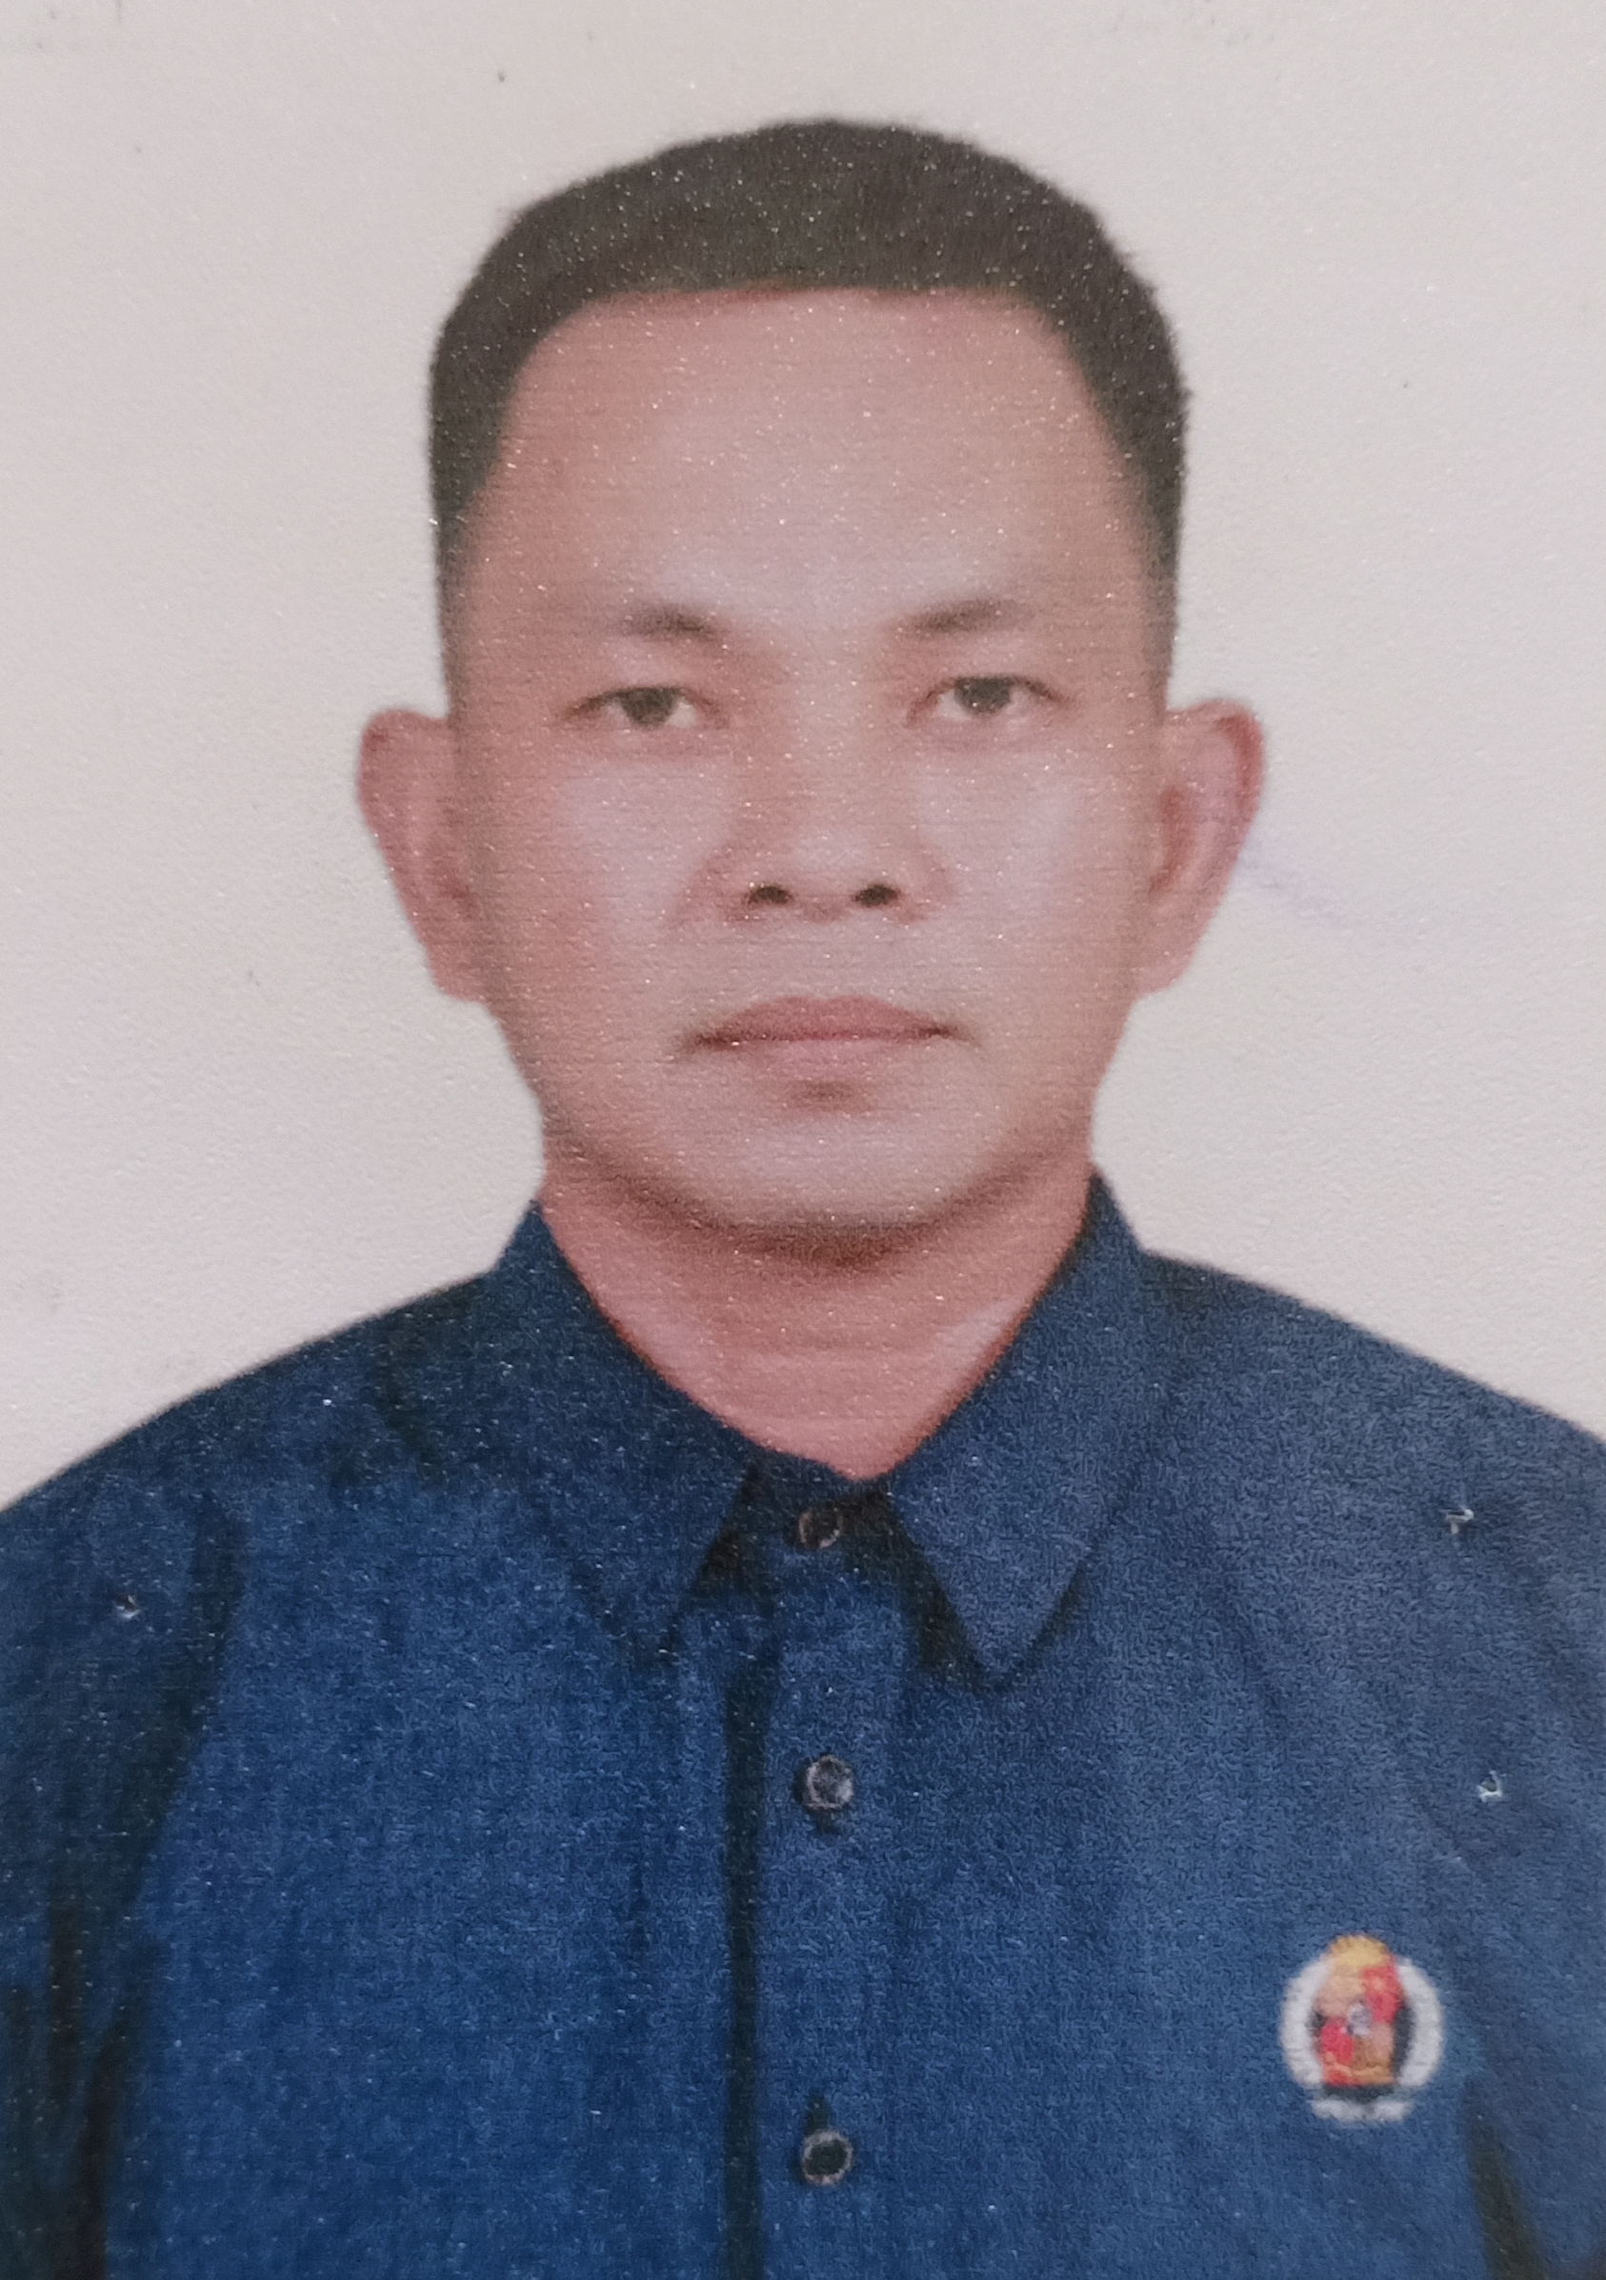
+63 09397407451
San Juan,Bato,Camarines Sur
Region V Philippines
PERSONAL INFORMATION Date of Birth: 08 April 1982 Place of Birth: San Juan, Bato, Camarines Sur, Philippines Gender: Male Nationality:. Filipino Civil Staus: Married Hieght: 5'6 ft Weieght: 68 klg. Religion: Roman Catholic Language: English,Filipino
QUALIFICATION SKILLS. Good communication skills
Flexible and hardworking
Positive attitude
Quick learners
Multi tasking
Ability to work under pressure
Self motivation

EDUCATION 1999 - 2003 Bachelor of Science in Criminology
University of Saint Anthony
Iriga City, Camarines Sur Philippines

1995 - 1999 Saint John Intitute San Juan,Bato,Camarines Sur Philippines

1989 - 1995 Atipolo Elemenary School
San Juan,Bato,Camarine Sur Philippines

WORK EXPERIENCE July 2007 - March 2019 Former military enlisted personnel rank of sergeant at Philippines Air Force.
HPAF Col. Villamor Air Base Pasay City, Philippines

July 2019 - December 2020 Security Officer
Robinsons Malls, Galleria South
Manila, Philippines

January 2021 to present Officer in Charge
Parkway Corporate Center
Filinvest, Alabang Muntinlupa City NCR Philippines

OBJECTIVES

Seeking a challenging job that gives me an opportunity to prove my creativity and combined my skills and talents with my immense desire for knowledge and experience to equip myself as a good worker.

