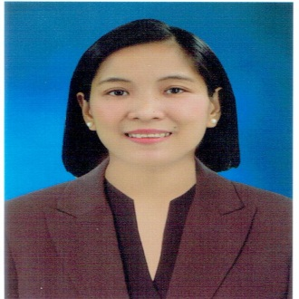
NELLY V. CULATA
Objective: To work in aggressive company as an committed employee. To share my ability for almost 15 years of my work experience.

PROFFESIONAL EXPERIENCE:
CONTACTS

Mobile +639489727833
Email:bloomvalenzuela@gmail.com
Address: 160 LABO ST. LA LOMA QUEZON CITY
1114 PHILIPPINES
Skype :LIVE CID.e350d265912990c7

MY INFORMATION

Birthday: March 11, 1986
Age : 36 yrs. old
Marital Status: Married

PROFILE
I started to work when I was 16 yrs. old because my parents don’t have enough money to support my studies. I am persistent to finish my studies despite of struggles I looked for a job and because of that I had a opportunities to find one. As a working student, I was able to learned how to managed my time from being working student . My dedication and hard work had paid off I was promoted as a TEAM LEADER/TRAINER from being Food Service Worker. I realized I was doing good in my responsibilities when it comes to my DUTIES as a Supervisor in the Company I’m working with. Like, I am knowledgeable in POS(point of sales) and Service Operation.
Committed hard worker with over 9 years of experience combining Management and Customer Service. Expertise in Customer Relation and 100% Handling Kitchen Station.

DENTAL ASSISTANT/DC DENTAL CLINIC (STA. MONICA MANILA) MARCH 09,2022 UP TO PRESENT
- Helping with infection control by sterilizing and disinfecting instrument trays preparing materials & assisting with dental procedures.
- Recording treatment information in patients records.
- Caring for dental equipment.
MACHINE OPERATOR WORK EXPERIENCE
FACTORY WORKER / TERAPOWER INC. (HSINCHU, TAIWAN) OCTOBER 12, 2016 – OCTOBER 07, 2019
- Handle more than 40 machine to check the quality and quantity of all IC products.
- Proper documentation of IC in every machine.
- Having 12 hours duty with open hour for overtime.
- Understand and follow the leader needs for everyday output.

FACTORY WORKER / AU OPTRONICS (TAICHUNG TAIWAN) MARCH 12, 2013 – MARCH 05, 2016

- Handle a large volume of LCD.
- Testing the monitor and cases.
- Carrying 10 to 15kilos of LCD monitor.
- Expertise to handle chemical products.
- Follow the standard policy of the company.

FASTFOOD WORK EXPERIENCE
SUPERVISOR / CHICBOY RESTAURANT (QUIAPO MANILA ) OCTOBER 21, 2011 – MARCH 05, 2013
- Supervised all the staff inside the store
- Conduct Company Orientation for the new product and service excellence.
- Update Training Materials and Data Base of Crew and Manager.
- Creating of Computing Sales Reports for Everyday operation and Daily Cash statement at the end of the month.
- In charge of Funds Management Security and Cash Control to all the Cashier, and Expenses and Daily bank Transaction.
- Prepared Inventory and Payroll processing.
- Manpower monitoring and schedule
- Knowing to handle the Delivery from commissary.

SERVICE CREW / MCDONALD’S PHILIPPINES (QUEZON CITY) MARCH 03, 2003 – MAY 09, 2011

I’ve worked abroad also as a MACHINE OPERATOR for 6 years. In order to fulfill my dreams for my Family in our Financial Needs. Since then, I never stop myself to look for a position where in a company that provide a career fast growth.
As an energetic person I am eager and eagerly to find a new career path that would drives me more for being motivated, enthusiastic with strong communication skills and team work abilities, having patience and dedication working in a long duty hours and willing to overtime if needed. And willing to share and help the company for all the knowledge and experienced that I’ve learned in the past that may help in the company.

EDUCATION

Bachelor of Science in Hotel and Restaurant Management (Graduate)
The University of Manila
(Manila Philippines) 2002-2009

SKILLS

*Computer literate
*Can work independently
*Customer Service Oriented
*Good Communication skills both oral and written.
*Capable of handling any problems and issues and resolved it right away.
*Willing to work under pressure and willing to help my co worker

- Performed duties according to the safety and security standards.
- Always follow the rules and regulation in every station.
- Took order from the customer arranged food item on serving trays and dine in and packaged foods for takeout, delivery orders. Well trained and performed in the kitchen, like cooking chicken mcdo, spaghetti, burger patties, fry products, I handle too breakfast products like cooking sausages, preparing hotcake mix and all stocks in preparation table in the kitchen.
- Process all payment transactions and accurately made change.
- Always recommend new products for selling up and up size meals.
- Resolved customer complaint.
- Meet the standard policy for customer satisfaction.
- Handle training for newly hired.
- I followed the procedure and preparation in cooking products based on the instructions provided.
- I always monitor the availability of our stocks.
- Responsible for reporting any incidents in the store. (IR)

TRAINING AND CERTIFICATES

- Practicum training in 1572 Restaurant and ballroom.
Dated: Dec 07 2007 to Feb 25 2008
@ Fernandina 88 suites hotel Cubao Q. C.
- Basic Shift Management Seminar.
Dated: Jan 17,18,and 19 2013
@ Chicboy and restaurant JP Rizal
- Best in Drive thru Crew Olympics metro manila Philippines
Dated: Feb 03 2009
@ McDonald’s QA Banaue

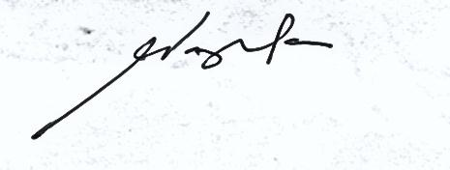

NELLY VALENZUELA CULATA
(APPLICANT)

