PEDRO MEDINA DACUT JR
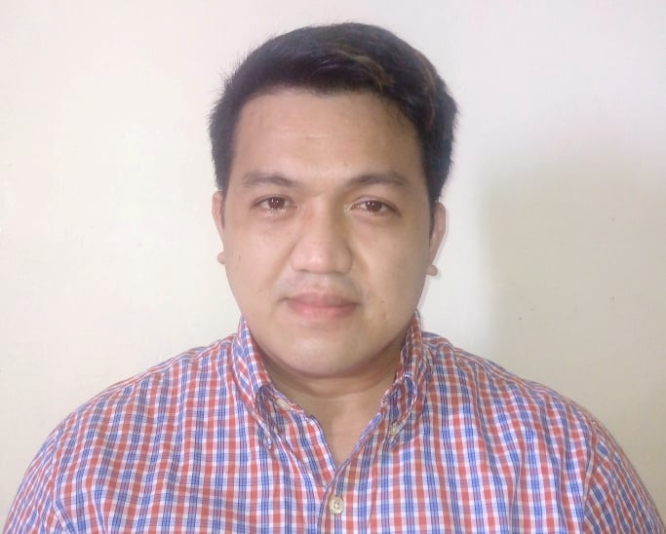
# 1889 Bonifacio st Brgy 178 Sitio Diwa Area-D,
Camarin Caloocan city. Philippines

Email address: dacutdondon2020@gmail.com
Phone: +63946 6124493

OBJECTIVE:
- Willing to learn and to contribute ideas on how to solve the certain problems.
- Willing to establish a good and effective relationship with people at all level.
- Can work with good attitude, highly motivated and past learner.

SERVICE RECORD:

NUTRITIVE/STATELINE
FIRST MAYON MULTI RESOURCES Inc. (agency)
Ass coordinator/Commando
JAN 05,2020 To Present

Job description: The Main Duties of Commando is substitute for Merchandiser Absent or No Duties, I’ve been refilling also the stocks in selling area until to make pully displayed. as a Commando’s or Assistant Coordinator, I’m reporting the the status of stocks in every outlet that I’ve been Visit, Inventory getting deliveries record, checking near expired, check first In First out, if sometimes the outlet has out of stocks or critical stocks I’ll talk to Visor/ manager to request stocks as soon as possible,

URC Universal Robina Corporation
CNT Promo Ads (Agency)
April 11,2017/Dec 31,2019
Merchandiser

Job description: URC’s product likes snack, (Piatos, Nova, Mr. chips, etc.) beverage, (C2, Blue energy drinks, REFRESH Mineral water)
Biscuits, (Cream-O, PRESTO, Pretzel, etc.)
The Duties as merchandiser, was to Refilling stocks in Selling Area, examined the Near expired, first In First out if have a new Deliver, Cleaning Gondola, shelve to make sure No dust, or Insect to stay. Responsibility, is to make sure the Product status, always Inventory.

Republic Biscuit Corp. REBISCO
July 30 2014 to Dec 29 2014
Novaliches Quezon City Philippines
Factory worker, warehouse

Job description: RBC and biscuit company from the Philippines, and I assign to warehouse my duties are to carry and take in delivery truck all boxes. Were also inventories all finished product.

CHIN CHU ENTERPRISE Co. LTD.
June 2011 to May 2013
Chia-yi shin Taiwan ROC 604
Factory worker, General Workers

Job description: chin Chu steel company had many departments and threes I was learning how to welding and grinder, how to paint to make finished the product.

EVER GOTESCO DEPARTMENT STORE
May 2006 to Oct 2006
Commonwealth Quezon city Philippines
Stockman

Job description: receive and sometimes to display the merchandise, and inventory the all merchandise in the stockroom.

SM SUPERMARKET
Sept 2005 to Feb 2006
Fairview Quezon city Philippines
Bagger

Job description: bagger assign in front area, they packed and box all product that they customer shopping, clean the area and return all product to the designated area.

BIG-R Supercenter
May 2004 to October 2004
Novaliches Quezon city Philippines
Salesclerk

Job description: Prices and arranges merchandise for display, replenishes stock and keep Display area orderly. Sells merchandise to customer and give information about the product and prices, take inventories.

SKILLS: forklift driving, basic welding, painter, typing (computer literate), food handle

EDUCATION:

2001-2003 St. John Technological College of the Phil's.
Bachelor in Science in Computer science
Novaliches Quezon city, Philippines

1997-2001 CAMARIN HIGH SCHOOL
Camarin Area-B Caloocan city Philippines
MARCH 1997-JUNE 2001 Graduate

1990-1997 CAMARIN D. ELEMENTARY SCHOOL
Camarin Area-D Caloocan city Philippines
MARCH 1990- JUNE 1997 Graduate

GENERAL DATA:
Date of Birth: April 07, 1984
Place of Birth: Caloocan, Manila Philippines
Civil status: Single
Height: 168cn cm
Weight: 80kg kilograms
Religion: Catholic
Gender: Male
Parent’s Name: Mr. Pedro Bagacay Dacut sr. and Mrs. Nimfa Dacut
Language Dialect: Tagalog and waray
Passport Numbers: P3664935A

CHARACTER REFERENCE:
Available upon request

