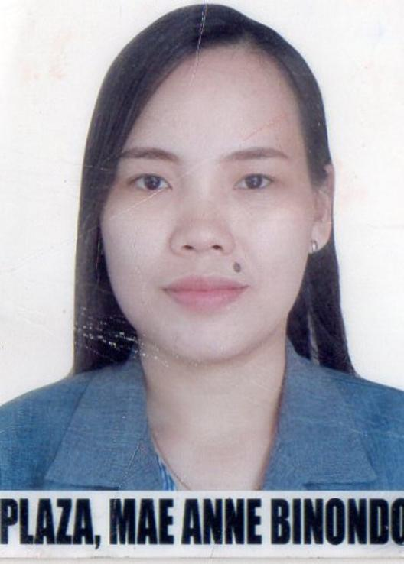
MAE ANNE B. PLAZA
Blk. D-10 Lot-6 S.I.R Matina, Ph. II
Davao City (8000), Philippines
Mobile: +63513620800 E-mail: eaveyancy29@gmail.com

OBJECTIVE
Compassionate Caregiver Companion with experience serving ill patients and to improve the life standard of elderly patients and keeping active as possible.

WORK EXPERIENCED
Present Work
Malasakit Center at Sounthern Philippines Medical Center
Health Worker 2016 –up to Present
Duties and Responsibilities;
- Assisted the indigenous patients in hospital and provide information about their medical needs assistance.
- Address were to give the guarantee letter such as medicine bill, hospital bill, laboratory bill and blood request.
- Provides the materials needed on the guarantee letters such as the government sealed and the SPMC approved stamp.

Part- time Caregiver
Mrs. Renisita P. Madelo, 65 yrs old/ Dialysis Patient
2018 to 2020
Duties and Responsibilities

- Serving as a companion to clients.
- Assisting with personal care
- Emotional and Social Support.
- Preparing medication needs for dialysis session
- Assist patient before and after laboratory test
- Taking vital signs
EDUCATIONAL ATTAINMENT
BACHELOR OF SCIENCE IN NURSING - COLLEGE GRADUATE ( 2010 )

CERTIFICATION AND SEMINAR
CPR Certification
First Aid Certification
Advance life Support Certification

