CAREER OBJECTIVE

JGEE JUSTIN OCAMPO
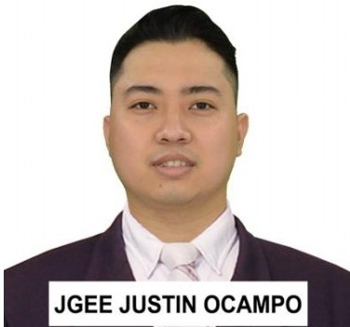
1548-A M.Natividad St. Sta.Cruz, Manila
+639219853559
jgeejustin@gmail.com

Versatile, skilled, and self-directing professional with an Automotive Engineering Technology Diploma and over 5 years of progressive experience in automotive repair and customer service. Offering robust organizational and problem-solving skills coupled with a passion working in a team or independently. Recognized throughout career as a "go-to" resource for quality work, dedication, and client support.

Physically fit and adept at juggling several pro jects at once, prioritizing duties, coordinating services, and thriving in fast-paced environment to strict deadlines. Strong communicator who effectively coordinates with various colleagues and senior management to finish all goals in timely manner.

KEY SKILLS

- Electrical & Mechanical Diagnosing
- Engine & Transmission Overhauling
- Vehicle Inspection & Repair
- Safety Policies & Procedures
- Interpersonal Communication
- Planning & Executions
- Problem Solving
- Time Management
- Computer Savvy

EDUCATION

2011-2014

2006- 2009

Technological University of the Philippines
Bachelor of Technology in Automotive Engineering Technology Ayala Blvd., Ermita, Manila

Cayetano Arellano High School
T. Alonzo Sta. Cruz Manila, 1008 Metro Manila

2000-2006 Andres Bonifacio Elementary School
Tayuman - lpil St. Sta. Cruz Manila, Philippine s

WORK - RELATED EXPERIENCE

ABDUL LATIF JAMEEL LTD. CO.
EI-Tadreeb EI-Mehani St. Sakaka, AI-Jouf Saudi Arabia.
October.27,2016 - November.30,2019

Toyota Abad Santos
2210 Jose Abad Santos Ave., M ani la June .2014 -June.2016

CERTIFICATION & TRAINING

August.12,2018 May.13,2018

June.11- 13,2019
Feruary .17 - 26,2019 April.19 - May.10,2019
Certified TEAM21 Toyota Pro-Technician Certified Team21 Toyota Technician

Toyota Team21 Diagnosis Electrical AC Training Toyota Team21 Diagnosis Electrical
Toyota Team21 Pro-Technician Training

PERSONAL INFORMATION

Date of Birth Place of Birth Age
Sex
Civil Status Citizenship Religion Height Weight
May.14,1994
Manila 27
Male
Married Filipino Catholic 168 cm.
170 lbs.

REFERENCES

Ahmed Sobhy
Service Advisor
Toyota Abdul Latif Jameel
EI-Tadreeb EI-Mehani St. Sakaka, AI-Jouf Saudi Arabia.

+966554854507

Mohammad Gamal
Service Advisor
Toyota Abdul Latif Jameel
EI-Tadreeb EI-Mehani St. Sakaka, AI-Jouf Saudi Arabia.

+966532088050

Cyrus Manongsong
Master Tech / Foreman
Toyota Abadsantos
2210 Jose Abad Santos Ave., M ani la June .2014 -June.2016
+639511136264



