

Glessie E. Lecciones
Area 1B Luzon Avenue Old Balara Quezon City
+639212513976
glessie89@gmail.com

OBJECTIVE
To be a part of a company that indulges professional growth which provides a challenging and rewarding career while allowing me to utilize my knowledge and skills.

PERSONAL INFORMATION
- Birthdate: April 2, 1989
- Height: 5’3
- Weight: 53kgs
- Citizenship: Filipino
- Civil Status: Single
- Religion: Catholic

EXPERIENCE
EMPLOYMENT GAP
FROM: November 20, 2021 – Present
REASON: Vacation and looking for a job

rESEARCH AND DEVELOPMENT ASSISTANT/ PASTRY PRODUCTION

| AMCA Fine foods inc. | November 2019 - NOVEMBER 19, 2021
- Responsible for developing new flavored cakes for institutional accounts.
- Developing and controlling formulation procedures for Caramia cakes and Gelato (Ice cream) products with an emphasis on product development.
- Conduct a trial run on existing products for standardization alignment.
- Worked in the lab for new product development.
- Knowledgeable of GMP, HACCP, and SSOP procedures.
- Passed reports timely on the head.

team leader PASTRY PRODUCTION | amici food service ventures inc. | October 2012 – November 2019
- Assist in keeping Department clean, hygienic, and tidy at all times.
- Work safety around equipment and monitor and deal with any maintenance issues.
- Always adhere to all company policies and procedures.
- Be involved and contribute at team meetings.
- Carry out the instruction given by the management team and head office.
- Prepares documents such as daily product Output, month-end inventory, Monitoring count, and other pertinent documents or reports related to manufacturing operation.
- Formulation of the In-process and cake finishing.
- Knowledgeable of processing Gelato, Gelato machine operation.

production staff (AMICI FOODSERVICE ventures inc.,)

4th dimension multipurpose coop. | November 2009 – October 2012
- Sanitize the table and utensils before the beginning of the production.
- Prepare materials needed from assembly to finishing of the cake.
- Always adhere to all company policies and procedures.
- Carry out the instruction given by the team leader.

EDUCATION

vocational - baking | June – December 2013 | eulogio amang Rodriguez institute of science and technology

secondary – del carmen national high school | 2002 - 2006 |
ELEMENTARY - DEL CARMEN ELEMENTARY SCHOOL 1997-2002

SEMINARS AND TRAINING
“CURRENT GOOD MANUFACTURING PRACTICES (CGMP) TRAINING” By Sonia De Leon
Amici food ventures Inc. | Chino Roces Ave., Makati City | August 17, 24, 31, 2013

CHARACTER REFERENCE
Jocelyn Yebra - Planner & Production Supervisor
(+6587938050 Singapore) (+639292066969 Viber)
Charmaine Marvida - Research and Development Specialist
(+639568427016)

I hereby certify that the above written and said information are true and correct to the best of my knowledge.
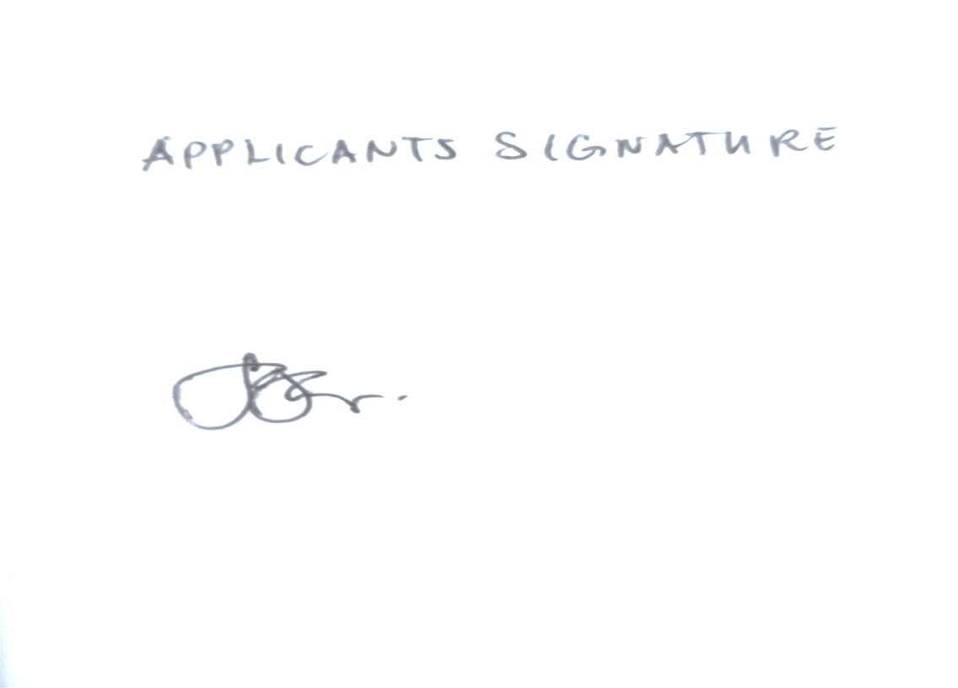

GLESSIE E. LECCIONES
Applicant Signature

