CURICULUM VITAE

A. Personal Identity 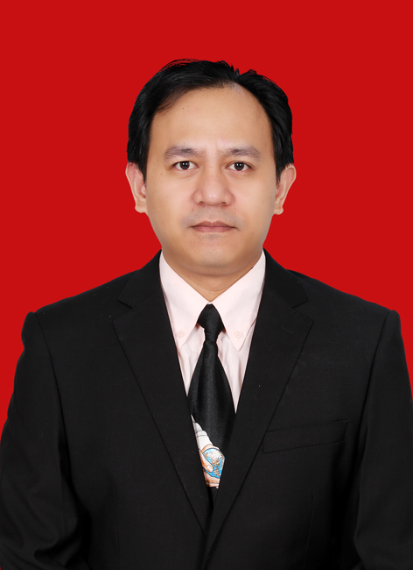

Name : Sena Prayoga
Sex : Male
Place/ Date of Birth : Bandung, 18 November 1979
Address : Griya Asri Cahaya Cipageran K 30 Cimahi Utara, West Java, Indonesia
Post Code : 40511
Phone Number : +628562206002
Email Address : sena.prayoga@gmail.com
Marital Status : Married
Number of children : 2 (two)

- Educational Background

No | Level | University and Program | Graduate / Title
1 | S2 (Master Degree) | INSTITUT TEKNOLOGI BANDUNG  West Java, Indonesia  Study Program: Physics Teaching  Thesis Title:  Modeling of Physics Teaching Through Inquiry-Based Learning for 8th Grade Indonesian Students  Advisor: Prof. Triyanta, Ph.D | January 18, 2016  / Master of Physics Education
2 | S1 (Bachelor Degree) | INSTITUT TEKNOLOGI BANDUNG  West Java, Indonesia  Study Program: Physics  Final Project Title:  Modeling of Tunneling Current in n-Type Metal-Oxide-Semiconductor Diode in Accumulation Case  Advisor: Prof. Khairurrijal, Ph.D | June 11, 2003  / Bachelor Degree of Science

- Research Experiences and Publications

No | Year | Research Title | Journal
1 | 2015 | Physics Teaching Through Inquiry-Based Learning in SMPN 1 Sukodono, East Java | Prosiding Seminar Kontribusi Fisika 2015, ISBN : 978-602-19655-9-7
2 | 2015 | Education in Taiwan to Face The Challenges of The Present and Future | SNIPS 2016, ISBN : 978-602-61045-0-2

- Award granted

The Best Graduates in Master of Physics Teaching in 2016 from Institut Teknologi Bandung

- Work Experiences

No | Year | Title
1 | 2018- now | Position: Physics Teacher  In SMAK 1 BPK Penabur Bandung
2 | 2013-2015 | Position: 2013 Physics Teacher and Mathematics Teacher  2014 Curriculum Teacher  2015 Head Master  In Citra Cemara Secondary School Bandung

- Training and Workshop

No | Year | Title | Level
1 | 2015 | Training Course on Earth and Space Science  Conducted by SEAMEO Regional QITEP in Science on August 4-13, 2015 | International
2 | 2014 | Workshop Computational Design Material – CMD ,  Instruktor : Prof. Hiroshi Nakanishi , November 13-14, 2014 CAS ITB | International
3 | 2014 | Pelatihan Implementasi Kurikulum 2013 bagi Kepala Sekolah, Kementrian Pendidikan dan Kebudayaan RI, 26-29 Mei 2014  (NewCurriculum for Head Master by Indonesian Government) | National

- Seminary

No | Year | Title | Level
1 | 2016 | Education in Taiwan to Face The Challenges of The Present and Future  as speaker on Simposium Nasional Inovasi dan Pembelajaran Sains 2016 at ITB,  July 21-22, 2016. | National
2 | 2015 | Modeling of Physics Teaching Through Inquiry-Based Learning for 8th Grade Indonesian Students  as speaker on Contribution Physics Seminary 2015 at ITB,  December 16-17, 2015. | National

Bandung, April 12, 2022

Sena Prayoga

