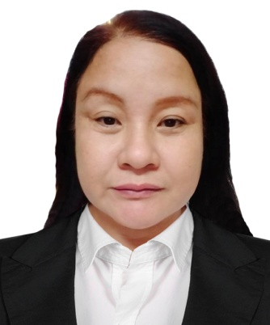
MARITES H. PAGMANOJA
Email : thesshombre1973@gmail.com
Mobile No. : 09166970248
Address : #416 Matiaga st A-4 Pinalagad Malinta Valenzuela City, Philippines
CAREER OBJECTIVES

“To take up a challenging career and grows with honesty, loyalty, good relationship, and best performance and translate my experience, knowledge, skills, and abilities into value for an organization.”
WORK EXPERIENCE

BUTCHER / MEAT CUTTER
CJ & G Meat Store / Pinalagad Malinta Valenzuela City, Philippines
April 2020 - Present
- Cutting, grinding and preparing meats for sale.
- Cleaning and maintaining tools and equipment and ensuring displays and signage are accurate and attractive.
- Weighing, packaging, pricing, and displaying products.
- Keeping records, budgets, and inventory.
- Performing quality inspections on meats and other products.
- Negotiating and confirming orders with suppliers.
- Adhering to food safety and sanitation controls.
- Greeting and speaking to customers, providing advice, answering questions, and accepting orders or payments.
- Coordinating deliveries or order pickups.

EDUCATION

UNIVERSITY OF SAINT ANTHONY
Iriga City Camarines Sur
School Year :1996
PALSONG HIGH SCHOOL
Bula Camarines Sur
School Year :1991

TRAINING

SLAUGHTERING OPERATIONS (SWINE) NC II
AGILE INSTITUTE AND BUTCHERING CORPORATION CALOOCAN
July 28, 2021 – October 22, 2021
FIRST AID / CPR CERTIFICATION
Bravo Zulu Philippines

