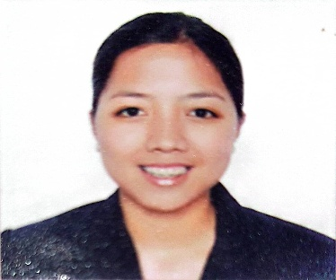
Dorissa Andrea Sugay Gonzales
Present Address: #2281 Granate St., Brgy.801 Sta.Ana,Manila,NCR
Cellphone No.: +6329778255500
E-mail Address: trissagonzales@yahoo.com

OBJECTIVE: To be a siginificant member of an institution where I can fully utilize and share my knowledge and further develop the same, and establish a harmonious work relationship with others.

PROFILE:

Permanent Address: Ilang-ilang st., Brgy.Sawmill,Gabaldon, Nueva Ecija
Age : 33 years old
Ht. : 5’8”
Wt. : 143 lbs.
Birthdate : November 27, 1987
Birth place : Makati City
Nationality : Filipino
Religion : Roman Catholic
Civil Status : Single

EDUCATIONAL ATTAINMENT:

College Degree : Bachelor of Science in Nursing
College of the Immaculate Conception
Cabanatuan City, Nueva Ecija

Secondary : Salutatorian
Nueva Ecija University of Science and Technology
Gabaldon, Nueva Ecija

Elementary : College of the Immaculate Conception
Cabanatuan City, Nueva Ecija

LICENSE:

Registered Nurse
License no.0516230
June 2008 – NLE passer

TRAININGS AND SEMINARS:

August 16, 2008 : Interactive Healthcare Seminar
Competent Nurses: Career Builders Production
Palayan Convention Center, N.E.

July 2-4 & 6-10, 2009 : Basic Safety Training
Southern Institute of Maritime Studies
Bacoor, Cavite

January 15, 2010 : Principles in Safe Administration in Medication
PNA: Nueva Ecija Chapter
Wesleyan University of the Philippines, N.E.

February 6-8, 2013 : Basic Intravenous Training Program
Accredited by ANSAP
Dr. PJGMRMC, Cabanatuan City, Nueva Ecija

March 8, 2017 : Customer @ Heart Always
Marie France Group of Companies
Makati City

WORK EXPERIENCE:

Clinical Instructor : November 2008 – December 2009
(Community Health Nursing) College of the Immaculate Conception
Nueva Ecija

Staff Nurse : January 16, 2009 – December 20, 2012
(General Ward) Eduardo L. Joson Memorial Hospital
Nueva Ecija

Nurse/Therapist : April 1, 2013 – March 14, 2016
(Beauty and Health) Marie France Group of Companies
Makati City

Head Nurse/Therapist : March 15, 2016 – present
Marie France Group of Companies
Makati City

QUALIFICATIONS:

Can work under pressure
Computer Literate
Willing to work on graveyard shift
Willing to undergo training

CHARACTER REFERENCE (upon request)

DORISSA ANDREA SUGAY GONZALES
Applicant

