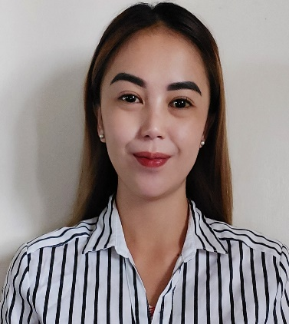
Estoesta, Michille P.
Simpa Ampucao, Itogon, Benguet, Philippines 2604
Contact Details: 0945-716-4492
Email: michilleestoesta28@gmail.com

OBJECTIVE: Seeking a position of English Teacher at your reputed school
for utilizing my educational qualifications and capabilities and be exposed to new ideas towards the achievement of the goals of the organization.

SKILLS:
- communication skills
- ability to teach and train students from different cultural backgrounds
- ability to motivate the students to converse in English language and provide them guidance to improve their writing, reading, and speaking skills
- ability to teach and treat students to develop their written and conversational skills
- ability to provide dynamic activities that caters to diverse students
- patience with students

PERSONAL DATA:
Date of Birth: December 9, 1989
Place of Birth: Dalicno, Itogon, Benguet
Age: 32 years old
Civil Status: Separated
Gender: Female
Religion: Roman Catholic
Nationality: Filipino
Language: Filipino and English

EDUCATIONAL QUALIFICATIONS:

TERTIARY EDUCATION:

University of the Cordilleras
Governor Pack Road, Baguio City Philippines
Master of Education in English
2021 (18 units)

University of the Cordilleras
Governor Pack Road, Baguio City Philippines
Bachelor of Secondary Education
Major in English
2015-2018

Universtiy of the Cordilleras
Governor Pack Road, Baguio City Philippines
Bachelor of Science and Nursing
Undergraduate
2006-2008

SECONDARY EDUCATION:
Sacred Heart High School of Itogon Inc.
Poblacion, Itogon, Benguet
2002-2006

ELEMENTARY EDUCATION:
Dalicno Elementary School
Dalicno, Itogon, Benguet
1996-200

WORK EXPERIENCE:

PrimeTalk Inc. (August 16- November 31, 2021)

- Business Communicator Instructor
- Teaches Business English to Japanese professionals.
- Enhance their communication skills that helps them with their work, business, and travel purposes.
- Provides adequate opportunity for students to explore and showcase their understanding and practice what they learned.

St. Joseph De Mary Academy Incorporated (August 2019 started as on call substitute teacher)
- Substitute teacher in facilitating the class in the absence of the adviser.
- Provides lecture and activities to students from elementary to senior and junior high school.
- Provides an environment for students to enhance and discover their potential in developing their own skills and knowledge.

Pines International Academy (September 2018- January 2019)
- Teaches English as a second language to Koreans, Chinese, Taiwanese, Japanese, Vietnamese, and Mongolians
- Caters to students with different ages and levels
- Provides a fun and engaging classroom

SEMINARS AND TRAININGS ATTENDED:

November 10, 2017- December 9, 2017 “WalangBatangBobo”
Outreach Program 2017

February 17-19, 2018 YOU Teach 2018
University of the Cordilleras
Governor Pack Road, Baguio City

March 23, 2018 Student’s Teachers Congress 2018
King’s College of the Philippines
La Trinidad, Benguet

May 24- 25, 2018 “Empowering Pre- service Educators for
the 21st Century Classroom”
UC Auditorium, University of the
Cordilleras Baguio City Philippines

September 4- 13, 2018 Teaching Empowerment Program for
English Educators (TEPEE)
Romel Mansion, Villamor Street,
Barangay Lualhati, Baguio City

April 29, 2019 120 hours teaching English to Speakers
of other Languages (TESOL)
TVE Enterprise, Baguio City, Philippines

April 29, 2019 120 hours of teaching English as a
Foreign Language (TEFEL)
TVE Enterprise, Baguio City, Philippines

June 9, 2021 “Understanding Dyslexia and Dysgraphia”
University of the Cordilleras
Governor Pack Road, Baguio City, Philippines

June 23, 2021 “Pedagogy in Creating a Gender and Language-
Sensitive Classroom”
University of the Cordilleras
Governor Pack Road, Baguio City, Philippines

July 14, 2021 “Teaching in the World of Millennials”
University of the Cordilleras
Governor Pack Road, Baguio City, Philippines

July 31, 2021 “Accommodating Learner’s Individual Differences:
Approaches and Strategies”
University of the Cordilleras
Governor Pack Road, Baguio City, Philippines

October 9, 2021 Research Ethical Consideration
University of the Cordilleras
Governor Pack Road, Baguio City, Philippines
Zoom Webinar

January 17-21, 2022 Indigenous People’s Education (IPED)
Orientation and Advocacy on IPED
NIIT, Baguio City, Philippines

January 24-28, 2022 Legal Basis of IPED
NIIT, Baguio City, Philippines

CHARACTER REFERENCES:

Merlita Saldaen Alma Biscocho Marlon Angaga
Alejandro L. Altiga Sr. University of the Cordilleras St. Joseph De Mary
Elementary School Instructor VP of Academic Affairs
Teacher 0910-989-5518 0915-431-4504
0948-693-3692

