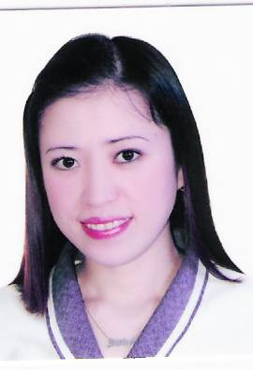
MICHELLE DELA CRUZ PEREZ
2247 Leveriza St. Malate, Manila
mobile # 0908-8179257
hermitchz@yahoo.com

JOB OBJECTIVE:

Be part of a working environment, which will aide in the development of my skills and personality.

EDUCATIONAL ATTAINMENT:

College Adamson University
Taft Avenue, Manila
Bachelor of Science in Pharmacy
1999-2002

Secondary Manila High School
Intramuros, Manila
1995-1999

Primary Aurora A. Quezon Elementary School
San Andres, Manila
1989-1995

EMPLOYMENT HISTORY:

Makati Medical Center
Team Leader Radiology Department
#2 Amorsolo St. Makati, City
+6328888999 loc.2284
September 2006-Present

Job Description:

- Maintain attentiveness to patient’s/customer’s needs, initiates steps that will comply with their requirements to meet and exceed their expectation.
- Maintain alertness on opportunities for service enhancement, endeavors to continually improve quality of work.
- Determine examination / procedure done to patients and bill them accordingly specifically for in-patients. Encode patients data and endorse to diagnostic technologist.

Pizza Hut Harrison Plaza
Cashier, Server, Assistant Marketing
Ground Floor Harrison Plaza Pasay City
+6325258870
February 2004- August 2006

Mc Donalds Harrison Plaza
Cashier, Server, My Store Marketing
Ground Floor Harrison Plaza Pasay City
+6325226889
June 2001- February 2004

SEMINARS AND TRAININGS ATTENDED AT MAKATI MEDICAL CENTER:

- December 2009
Clinical Practice Guidelines
- Patient's Complaints.
(How to Stop them Before they Start.)
- January 2010
Common Communicable and Infectious Disease
- Communication Building Bridges, Bridging Gaps.
- February 2010
Building a Better Guide for Professional Life.
- February 2011
International Patient Safety Goal (IPSG)
- March 2012
Service RecoverY
- August 2012
A Healthy Dose of English
- August -January 2020
Institute for Healthcare Improvement (IHI)
- October 2020
Leaders and Coaches Program

ON-THE-JOB-TRAINING- Assistant Pharmacist
Mercury Drug San Andres Malate, Manila
October 2001

ACHIEVED AWARDS:

Best in Cashier
Mc Donalds Harrison Plaza
January 2004

Crew of the Year
Mc Donalds Harrison Plaza
December 2003

SKILLS AND CAPABILITIES:

-Quick Learner
-Team Player
-Effective Management Skills
-Good in Oral and Written Communication
-Computer Literate
- Can work well without the supervision.

PERSONAL DATA:

Birth date July 27, 1983
Age 37 years old
Sex Female
Civil status Married
Height 5’2”
Weight 132 lbs.
Nationality Filipino
Religion Roman Catholic

CHARACTER REFERENCES:

Maria Lena Ablis-Sun, MD
Radiologist, Diagnostic Section
Radiology Department
Makati Medical Center
+639178821198

Mrs. Rufina Agliam
Assistant Unit Manager
Radiology Department
+639993571776

Ms. Laura Perido
Department Manager
Radiology Department
+639088189408

I certify that the above information is true and correct at the best of my knowledge and ability.

MICHELLE DELA CRUZ PEREZ

