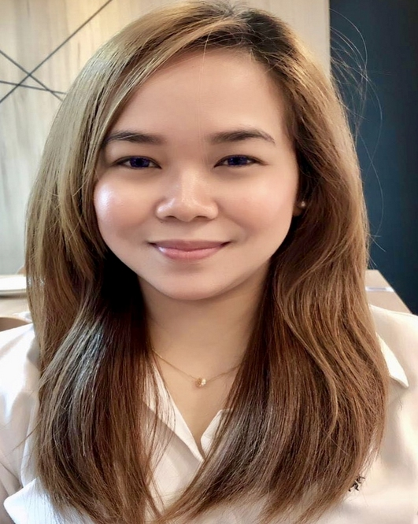
LINVEDEL ANN SALALAC JULIANO

Block 10 Lot 15, Bellefonte Subdivision
Camarin, Caloocan City
Philippines

Mobile Number: (+63) 9682244254
E-mail: wornout_coniata_10@yahoo.com

JOB OBJECTIVE:
Seeking a position to utilize and share my knowledge, skills and abilities that will suite my previous work and be an asset for the progress of your company.

PERSONAL INFORMATION:

Date of Birth: 12 November 1988
Place of Birth: Quezon City
Age: 32 years old
Sex: Female
Citizenship: Filipino
Religion: The Church of Jesus Christ of Latter-Day Saints
Common Law Husband: Arnolfo L. Ganceña
Son: Andrei Julian J. Ganceña

EDUCATION:

Tertiary Education:
Bachelor of Science in Nursing
Far Eastern University- NRMF
SY 2005-2009

Secondary Education:
Our Lady of Fatima University
Hilltop Mansion, Lagro, Quezon City
2001-2005

Primary Education:
Lagro Elementary School
Quezon City
2001

SKILLS:

- Proficient in MS Word, Windows XP, and Internet
- Speaks English and Filipino
- Relate well to people from a variety of cultures
- Adaptability and ability to work under pressure
- Has a basic knowledge in using NovaPOS
- Energetic, Friendly, Pleasant, Success/Result-Oriented and Enthusiastic.
- Exceptional Customer Service.

SEMINARS ATTENDED:
DISASTER NURSING
RED CROSS DISASTER MANAGEMENT CENTER- April 24 - 26, 2008
Red Cross Quezon City
SAFETY FIRST AID and BASIC LIFE SUPPORT- November 15 - 20, 2010
Red Cross Quezon City
REGULAR INTRAVENOUS TRAINING PROGRAM- March 1 - 3, 2011
Martinez Memorial Hospital- Caloocan City

AFFILIATING AGENCIES:

- Far Eastern University Medical Center
- Philippine Orthopedic Center (Ortho)
- San Lazaro Hospital (Communicable Diseases)

---------------------------------------------------------------------------------------------------------------------

WORKING EXPERIENCE:

Singora Pte. Ltd (Missoni/M Missoni/Multi Labels)
Singapore

Position: Senior Sales Associate
January 14, 2020 – August 30, 2020
Salary: $2500

Job Description:
- Assess customer’s needs and provide assistance and information on product we are selling.
- Remain knowledgeable on the products offered (e.g. fabric, sizes, colors) and discuss available options.
- Assist the customer in trying clothes, suggesting sizes or colors if necessary.
- Cross sell products.
- Building productive trust relationship with customers.
- Ensure high levels of customer satisfaction through excellent sales service and always be ready to “go the extra mile”.
- Handle returns of items.
- Process Point of Sales purchase.
- Team up with colleagues especially when hitting quota.
- Doing inventory once a week and make sure everything is correct and tally.
- Maintain the cleanliness of the shop.
- Suggesting ways how to improve sales with the team.
- Give training to the staffs assigned under me on how to boost sales. Welcome customers to the store actively with a happy face and answer their queries.

--------------------------------------------------------------------------------------------------------------------

Mena House of Fashion (Maghrebi by Sheenaz Fazreen)
Singapore

Position: Senior Retail Assistant

From: August 14, 2018 – December 30, 2019
Salary: $2200 Basic

Job Description:

- Welcome and greet customers as they enter the shop.
- Introduce the Middle Eastern and North Africa items, mainly Morocco.
- Assist the customer and answer questions related to the merchandise and store policies and locate items.
- Process payments and pack items in a presentable way.
- Update sales records and replenish items on the display areas.
- Do the inventory and receive replenishment stocks once a week.
- Maintain the cleanliness of the shop always.
- Meet more than the satisfaction level of the customers.
- Doing settlement at the end of the day using NovaPos.
- Doing trainings for junior associates on how to increase their sales and hit target.

---------------------------------------------------------------------------------------------------------------------
Jericho Cosmetics Singapore (Dead Sea Minerals)
Singapore

Position: Senior Sales Executive
From: May 1, 2016 – June 20, 2018
Salary: $2000 – Basic
$500 to $1000 - Commission

Job Description:

- Look for a potential customer and get their attention to stop then bring inside the shop.
- Explain to customer the importance of Dead Sea product for wellness.
- Make sure the customer satisfaction and close the deal.
- Process the payments and be able to establish good relationship with new customers before they leave the shop to make them regular customers.
- Doing inventory and cleaning the shop every after shift.
- Doing trainings for junior associates on how to increase their sales and hit target.

ACHIEVEMENT:
- Top Sales Performer and Teamwork for the First Quarter of 2016

---------------------------------------------------------------------------------------------------------------------

WorkHome Personnel
Singapore
Position: Executive Consultant
From: January 4, 2016- March 4, 2016
Salary: $2000 (Basic + Allowance)

Job Description:
- Visiting the client sites on a regular routine let them fill up bio data and key in their profile in our company website.
- Analyze various issues at the client's place and search for the exact problem.
- Undertake various methods to identify issues and form hypotheses.
- Create various recovery plans according to the exact problem detected.
- Interact with the clients and explain them about the problem and their drawbacks.
- Suggesting and explaining various solutions to the clients.
- Implementing the solutions until the problem is recovered.
- Documenting each and every research undertaken during the problem solving process.
- Undertaking effective research and data collection.
- Interacting or interviewing the clients, management personnel, and other responsible people to effectively analyze the problem.
----------------------------------------------------------------------------------------

Manulife Business Processing Services
Philippines

Position: Business Processing Associate
Team: GB Plan Design, Plan Sponsor Services, Coverage New Issue

From: April 02, 2013- March 28, 2015

Job Description:
- Execute, process and administer a broad range of financial transactions for Manulife Hong-Kong, Canada and US business units.
- Handles email correspondence (English).
- Responds to clients’ correspondence with good judgment and high analytical skills.
- Prepares monthly/quarterly reports based on data queried from system
- Processes, reviews and administers customer requests/policy transactions (as and when assigned).
- Maintain accurate record of business transactions and document analysis
- Reports to Team Leader and coordinates with business unit abroad for work assignments.
TOWNHALL ACHIEVEMENTS:

- Best in Accuracy for the month of August 2013
- Best in Accuracy for the month of April 2014
- Best in Accuracy for the 3rd Quarter 2013

----------------------------------------------------------------------------------------
TOWNHALL ACHIEVEMENTS:

- Best in Accuracy for the month of August 2013
- Best in Accuracy for the month of April 2014
- Best in Accuracy for the 3rd Quarter 2013

REFERENCES:

Dra. Donalisa M. Guiao
Dra. Guiao Medical Clinic
09178126205

Dra. Visitacion Toy
The Medical City- Fairview
09193438611

Mrs. Ranchenel Tapia Pagaran
Boston Imaging (Radiology) and Diagnostic Pte Ltd.
Radiographer/Sonographer
(+65) 84526963

Mrs. Salbiah Rais
Singora Pte. Ltd
Admin cum HR
(+65) 96924394

