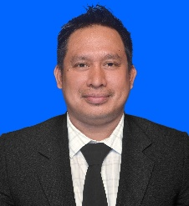
I DEWA PUTU SIDIARTA
Denpasr,Bali - Indonesia
Phone : 0813 5339 9560/0813 5374 1779
Email : pandewa76@gmail.com

CURRICULUM VITAE
EDUCATION :
Dhyanapura Hotel & Tourism Training Center Major in Hotel Departement Management 1994 -1996
Tourism High School Bali,Major in Sociality and Tourism 1991-1994

WORKING EXPERIENCE:
PRESENT
Catering Service
Cook for sale local community with domestic menu

WINTER 2008 – 2013
Restaurant Manager at Ru San’s Japanese Restaurant
1220 Caroline St NE,Atlanta, Georgia, USA
Responsible in coordinating daily restaurant management operation as well as maintain productivity,quality
Customer service standards.

SUMMER 2008
Sous Chef in The State Game Lodge at Custer State Park Resort Company South Dakota,USA
Responsible for all of food stock appropriate to sales level and not over ordered and proactive in
Problem solving praise and recognize good performance

WINTER 2007
Sous Chef at Spanish Well Country Club in Bonita Springs,Florida,USA
Responsible and fills in for the chef assist the station chef/line cook as necessary check all
Stations such as grill and sauted in well prepared.

WINTER 2006
Senior Line Cook at Harbour Ridge Yacht and Country Club,Palm City Florida,USA
Responsible for all sautéed items and their sauces preparing and make sure all line set-up ready
For dinner ala carte

WINTER 2002
Busser and Food Runner at Harbour Ridge Yacth and Country Club Palm City Florida,USA
Cleared-up tables and reset-up as needed and responsible for assist servers to delivered food orders

1996 – 2001
Front Desk/Reception at The Legian Bali Hotel,Bali Indonesia
Responsible for selling guest room,registered guest and designed guest room
Provides assistance to the guest during their stay and receives payment

