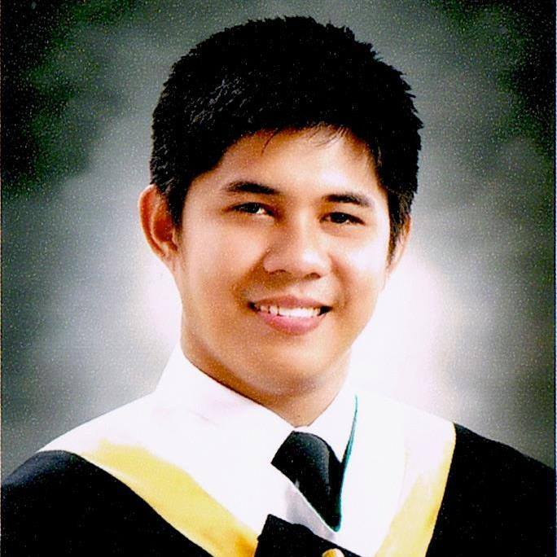

EMMAN NOEL FLORES, BSN, RN
emmannoelflores@gmail.com
09983411319

JOB OBJECTIVE

Skilled and experienced nurse professional looking for a more challenging and responsible role of a health care giver where my skills, knowledge and experiences can be enhanced and utilized efficiently and effectively in achieving the goal of patient- centered care.

PERSONAL DETAILS

DEGREE : Bachelor of Science in Nursing
ADDRESS : Block 8 Lot 41 Sunberry Homes, Soong, Lapulapu City
BIRTH DATE : May 13, 1990
CIVIL STATUS : Single
SEX : Male
RELIGION : Roman Catholic
CITIZENSHIP : Filipino

EDUCATIONAL BACKGROUND

TERTIARY Bachelor of Science in Nursing (BSN)
University of San Carlos – Technological Center
Talamban, Cebu City, Cebu, Philippines
2008- 2012

SECONDARY St. Teresa School of Hilongos
Hilongos, Leyte, Philippines
2003- 2007

ELEMENTARY St. Teresa School of Hilongos
Hilongos, Leyte, Philippines
1997- 2003

PROFESSIONAL EXAMINATION TAKEN

Professional Regulation Commission (PRC)
Name of Examination : Philippines Nurse Licensure Examination
Date Taken : December 2012
Place Taken : Cebu City, Cebu, Philippines

PROFESSIONAL ORGANIZATIONS

Member
Philippine Nurses Association of the Philippines (PNA)
Cebu Chapter, Cebu City, Philippines

RELATED NURSING EXPERIENCE AFFILIATIONS

- Bogo District Hospital (BDH)
- Cebu City Medical Center (CCMC)
- Lapu Lapu City Hospital (LLCH)
- Daanbantayan Dstrict Hospital (DDH)
- Vicente Sotto Memorial Medical Center (VSMMC)
- Hilongos District Hospital (HDH)
- Ormoc District Hospital (ODH)

WORK EXPERIENCE

Department of Health – Region VIII Nurse Deployment Project (NDP)
(January 2014 - December, 2015)

WIPRO Device Analyst (Boston Scientific)
(November 2016 – February 2018)

Hilongos District Hospital Nurse (Job Order)
Province of Leyte (August 2019 – December 2020)

Department of Health – Region VII Nurse Vaccinator (SIA Program)

(February 2021)

Department of Health – Region VII Nurse Vaccinator (COVID-19)
(May 2021 – Present)

PREVIOUS JOB DESCRIPTION

Public Health Nurse
- Assists in the implementation of various health programs of the Local Government Unit in accordance with the program goals and objectives of the Department of Health and the Health Sector.
- Provides technical assistance in the implementation of the health programs.
- Assists in the conduct of disease surveillance.
- Conduct Health education and training.
- Assists in the supervision and monitoring of the Community Health Team (CHT).
- Assists in conducting of the regular monitoring and evaluation of the various health programs for the community.
- Assists in the preparation and analysis of reports on clinic and community activities.
- Submits monthly accomplishment report and DTRs to the CHD through Public Health Nurse describing the highlights of their activities, targets and accomplishments, learning insights, issues/concerns and recommendation.
- Performs other related functions as may be assigned.

CHARACTER REFERENCES

- Dr. Ariel Hembra
Physician
09472186363

- Hon. Crstuto Ong

Hilongos, Leyte

09176340662

- Dr. Joseph Jay Abueva

Physician

09209683661

