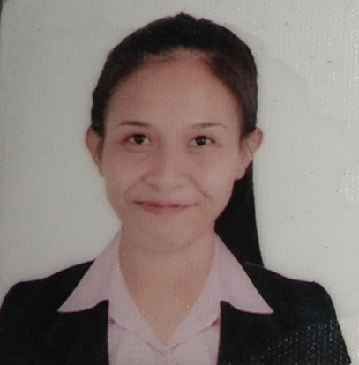
MITCH G. OBOZA
16th De Agost St. Pasay City, Philippines
Mobile: +639216445826
E-mail Address: mitchgoboza@gmail.com

OBJECTIVES:
To obtain a position which I haven’t had an opportunity to work in that would enhance my skills, capability, and experiences.

Work Experiences:

Accounting/Sales Assistant Cash & Carry Supermarket Filmore St Palanan Makati City,Philippines
(December 2018- Present)

Duties and Responsibilities
- Prepare Daily Sales Report through GL System and WINVQP System
- Summarizes and submit report daily to the store manager.
- In charge of Concessionaires' Monthly Billing ( Dry goods section).
- Maintain and update POS Sales Books
- Monitoring the daily shortages of cashiers.
- Supervise Sales Section

THE FRENCH BAKER
Service Crew
Sm Megamall / Robinson’s Galleria Ortigas
(July 13, 2017-August 6, 2018)

Duties and Responsibilities
- Interact with Customers
- Use Selling Techniques
- Clean
- Maintain Stock
- Greet Customers
- Fill Food Orders

PERSONAL INFORMATION:

Gender : Female
Age : 25
Birthdate : August 16, 1996
Birthplace : Magalang, Pampanga
Civil Status : Single
Nationality : Filipino
Languages : English, Filipino, Ilocano
Religion : Roman Catholic
Height : : 5’1
Weight : 46kgs.

EDUCATIONAL BACKGROUND:

Tertiary : Bachelor of Science in Business Administration Major in Operations Management
Pangasinan State University
Alaminos City Campus
Bolaney, Alaminos City, Pangasinan
(2013-2017)

Secondary: Burgos National High School
Poblacion Burgos,Pangasinan
(S.Y 2009-2013)

CHARACTERISTICS:
- Fast learner
- Ability to meet deadlines
- Excellent in dealing with other people
- Can work under pressure

SEMINARS/TRAINING ATTENDED:

Reserve Officer’s Training Corps
Lingayen Pangasinan
February 26, 2014

AFFILIATION:

Society of Young Business Administrators ( SYBA )
Pangasinan State University Alaminos City Campus

CHARACTER REFERENCES:

Available upon request.

I hereby certify that all the above information is true and correct to the best of my knowledge and belief.

MITCH G. OBOZA
Signature over Printed Name

