BOCALES, MARICRIS LANGCAO  ALULING, CERVANTES ILOCOS SUR  09460624116 | 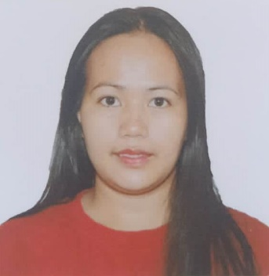
EDUCATIONAL INFORMATION
TERTIARY : BS Accountancy
University of Baguio
Baguio City
Undergraduate
SECONDARY : Loo National High School
Buguias, Benguet
April 2008
ELEMENTARY : Mt. Data Elementary School
Bauko, Mt. Province
April 2002

SKILLS AND QUALIFICATIONS
-Basic and proficient computer application experience
-Microsoft Office Applications
-Communication Skills
-Business Awareness
-Organizational Skills
-Cullinary Skills
-Handicraft Skills

WORK EXPERIENCE
Secretary
CASRA Cervantes
Ilocos Sur
2019-2021
Domestic Helper
Singapore
2011-2012

PERSONAL INFORMATION
DATE OF BIRTH: December 25, 1987
PLACE OF BIRTH: Bontoc, Mt. Province
AGE: 34
GENDER: Female
CIVIL STATUS: Married
CITIZENSHIP: Filipino
FATHER'S NAME: Marvin Langcao
MOTHER'S NAME: Angela Langcao
HEIGHT: 5''
WEIGHT: 69kg
LANGUAGE/DIALECT: Kankana-ey, Ilokano, Tagalog, English

CHARACTER REFERENCES
-Available upon request.

