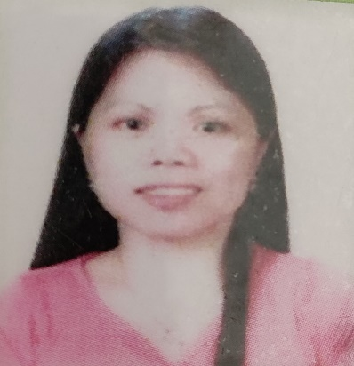
SYLVIA CAYUBE CENTENO
No. 9 Brgy. San Antonio Santo Tomas
City of Batangas 4234
Email add: richbave@gmail.com
Mobile: 09293704100

WORK EXPERIENCE
Caregiver
June 18, 2006 – September 18, 2017
Haifa Israel
Duties and Responsibilities:
Live in caregiver.
Personal and social caretaking and supervision.
Assistance in consumption of medications and daily needs.
Assistance for doctor’s check-ups and hospital confinement.
Assistance in managing the household,

Production Operator
October 26, 1994 – June 30, 2004
Read Rite Philippines Incorporated
Canlubang Calamba Laguna
Duties and Responsibilities
- Perform any stations qualified as required by the documents process control plan.
- Aligning and Bonding of heads into the arm.
- Testing of units to test the electrical parameters.
- Check the resistance of required parameters.
- Inspect the visual criteria as required costumer specification.

Training Department Assistant
- Assist on training activities.
- Encoding, Indexing, Updating and Filing of all training documents.
- Inventory skills orientation and qualification papers.

SKILLS
Basically computer literate (MS Word, MS Excel, Power Point)

EDUCATIONAL ATTAINMENT

Vocational-Computer Programming
System Technology Institute Calamba
1997 – 1998
Secondary
Bukal Sur National High School
Taguan Candelaria Quezon
1993 - 1994
Primary
Buenavista West Elementary School
Taguan Candelaria Quezon
1988 – 1989
PERSONAL DATA
Name of Father: Carlito A. Cayube
Occupation: Deceased
Name of Mother: Leticia C. Cayube
Occupation: Senior Citizen
Date of Birth: June 02, 1976
Birth Place: Candelaria, Quezon
Age: 45
Status: Married
Height: 152cm
Weight: 52 kilos
Nationality: Filipino
Religion: Catholic

I hereby certify that the above information is true and correct to the best of my knowledge.
 SYLVIA CAYUBE CENTENO
Applicant

PASSPORT #: P8839508A
Date of issue: September 21,2018
Validity: September 21, 2028
TIN: 176-971-194
SSS: 04-0776237-8
PAGIBIG: 121062618170
PhilHealth: 19-026057956-1

