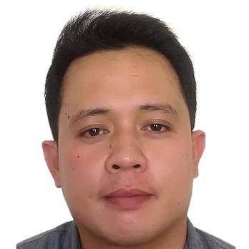
ROMCEL A. DORO-ON

PERSONAL INFORMATION
ADDRESS:

Block 1, Lot 41, Jolly Orange street, Jeth Village, Barangay Visayan, Tagum City, Davao del Norte, Philippines, 8100

DATE OF BIRTH
June 11, 1984

PLACE OF BIRTH
Tagum City

AGE
36

CIVIL STATUS
Married

PHONE NUMBER
+639333234485

E-MAIL ADDRESS
romcel061184@yahoo.com
SKILLS
- Can develop and sustain positive relationships to obtain goals and objectives of this institution;

- Moderate communication skills (verbal and written);

- Can employ effective solutions in a timely manner;

- Detailed and action oriented

- Computer Literate (MS Word, MS Excel, MS Publisher, Adobe Photoshop, Adobe Premier)
GIS Specialist
LANGUAGE
English
Tagalog

CAREER OBJECTIVE

- To make use of my interpersonal skills to achieve goals of this institution that focuses on BEST PEOPLE;

- Seeking and entry-level position to begin my career in a moderate-level professional environment;

- Secure a responsible career opportunity to fully utilize my skills, while making a significant contribution to the success of this institution

WORKING EXPERIENCE
2010 - Present Provincial Engineering Office and
Provincial Planning and Development Office

EDUCATION
ELEMENTARY
1991 – 1997 Kapitan Tomas Elementary School
Davao City
SECONDARY
1997 – 2001 Rizal Memorial Colleges
Davao City

COLLEGE
2003 – 2008 Bachelor of Science in Civil Engineering
Saint Mary’s College
Tagum City

Romce A. Doro-on
Applicant

