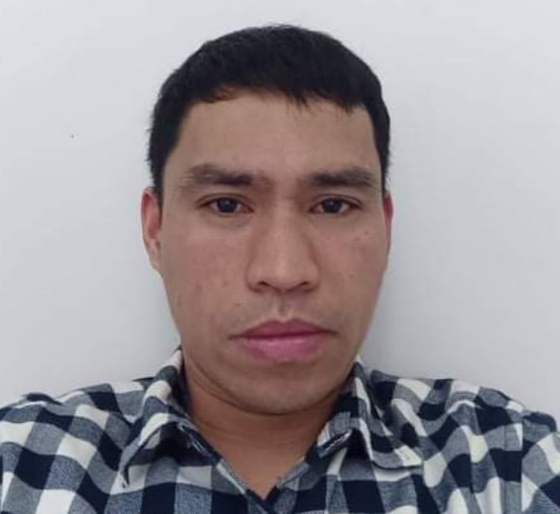
Distor, Jeremias Valmonte
Okayama Ken Kurashiki-shi Kojima Shionasu
350-1 Village House Building 2 Room 203 Japan 711-0934
Contact Number: 09473233237
Email Address: jerits@yahoo.com

OBJECTIVE:
I seek challenging opportunities where I can fully use my skills for the success of the organization.

PERSONAL INFORMATION:

Date of Birth : June 25, 1981
Age : 40 years old
Gender : Male
Civil Status : Married
Name of Spouse : Julie Ann Distor
Citizenship : Filipino
Religion : Born Again Christian
Height : 5’5”
Weight : 64kgs.
Languages/Dialects : Tagalog, English and Nihongo

EDUCATIONAL BACKGROUND:

College/Course : Urdaneta College of Technology
Associate in Electrical Technology
1998-2000

: Fil-canadian Training and Development
Center for Caregivers Inc.
6 Months Caregiver Training Course
September 02, 2004 March11, 2005

Secondary : Don Benito, High School
Don Benito, Pozorrubio, Pangasinan
1994-1998

Elementary : Don Benito Elementary School
Don Benito, Pozorrubio, Pangasinan
1988-1994

Special Skills: Driving, Pig Butchering, Electrical wiring, Painting

Training and Seminar Attended:

October 1999-March 2020 : Pangasinan Electric Cooperative Inc. (PANELCO)
Urdaneta City, Pangasinan

August 27, 2004 : HOSPICE CARE
Pangasinan Association of Caregiving Institution
Divine World Academy GYM, Dagupan City

February 05, 2006 : Care of New Born/ New Born with Disability

WORK EXPERIENCE:

January 08, 2008 – January 08, 2011 : Welder
Hiroe Kogyo, Japan
Technowood Construction Enterprises
February16, 2016- Up to Present : Welder
Hiroe Kogyo, Japan
Technowood Construction Enterprises

Job Description:
- Prepare the materials for the accordance with structure.
- Measure and cut the materials for the project.
- Assemble it by tack weld after it form it as a while, then fill weld it.
- Capable to weld flat sheet pipe in any position , vertical, horizontal, downhill, uphill, using helium and argon or carbon dioxide.
- Set up the rolled large sheet in opposite side as one shell, fit it with tack weld.
- Preheat the joining level from 80 degrees Celsius to 100 Celsius after weld it by root pass, hug pass and capping.
- Fabricating of steel column girder and trusses.

Tools and Equipment:
- Use Panasonic Auto welding machine
- Use miller welding machine
- Use limcoln welding machine
- use automatic cutting and plasma cutting tools

Career Related Skills:
- Driver (Light Vehicles)
- Welder

CHARACTER REFERENCES:

Joedel R. Delos Reyes
Branch Manager
Fil-Canadian
3/F., Canadian Training and Dev’t Center for Caregivers Inc.
3/F., T and S Building., San Vicente, Urdaneta, Pangasinan
Tel. No. (075) 624-2551

Jerome Empleo
Overseas Workers
San Mateo, Rizal
Tel. No. 55017509

Nerissa Mencias
Teacher
Benigno V. Aldana National High School
Cellphone No. 09166022370

I hereby certify that the above information is true and correct to the best of my knowledge and belief.

JEREMIAS VALMONTE DISTOR
Applicant’s Signature

