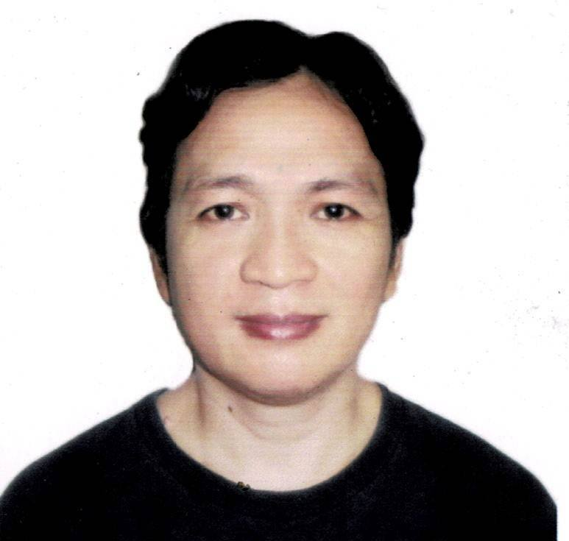
Herbert Joey Guevarra
1199 Kagitingan st.Tondo, Manila 1012 Philippines
Contact numbers: 09957305702/09610900282
Email: yeojguevarra04@gmail.com

PERSONAL INFORMATION

Permanent Address : 1199 Kagitingan st.Tondo, Manila
Birthdate : April 27,1979
Birth Place : Manila Philippines
Height : 5’4" ft.
Weight : 140 lbs.
Sex : Male
Civil Status : Married
Religion :. Christian
Nationality : Filipino

EDUCATIONAL BACKGROUND

Elementary Year
School : Holy Child Catholic School 1991
Address : Tondo,Manila Philippines

Secondary
School : Philippine Christian University 1995
Address : Taff ave.,Manila Philippines

Tertiary
Course : Tool and Die Engineering Technology 1995-1999
School : Technological University of the Philippines
Address : San Marcelino St., Ermita, Manila, Philippines

EMPLOYMENT HISTORY

Position : Ambulance Driver
Company : City of Manila - Ospital ng Tondo
Address. : Manila city
Date. : 2021 January - Present

Position : Building Maintenance
Company : McDonald’s Canada
Address : Edmonton, Alberta Canada
Date. : 2012 October - 2015 December
Reason for Leaving : Finished Contract

Postion. : Food counter attendant/Building Maintenance
Company : Golden Arches Development Corp. (McDonald’s Philippines)
Address. : Kalaw St. Ermita Manila Philippines
Date. : 2007 April - 2012 September
Reason for Leaving : Moving to McDonald’s Canada

Character reference ; to be follow or upon request

