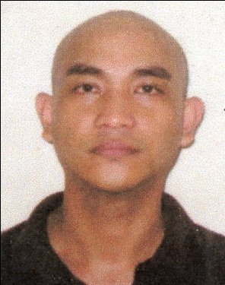
Deneve P. Soltes

#91 Sampaguita Street. Phase 2 CAA Las Piñas City.
Mobile number: +639687450488
deveneyohanne@gmail.com
Applying for Customer Service Representative or Galley Utility
OBJECTIVE:
To work in a reputable company that i may qualify with.Which can utilize my knowledge and skills and at the same time enhance my ability while providing opportunity.

EMPLOYMENT HISTORY
Name of company From -to. Reason of leaving

ARB Call Facilities 09/0919 – present
Teleperformance 01/2019 – 04/16/19 resigned
1Aviation/Cebu Pacific 02/19/17 – 09/20/18 end of contract
Costa Diadema 03/23/16 – 6/22/16 resigned
Costa crociere/magica. 02/16/15 - 11/11/15. end of contract
Compagnie du ponant. 06/16/13 - 4/13/14 end of contract
Celebrity millenium. 01/10/11 - 9/28/11. end of contract
Celebrity century. 05/21/10 - 11/22/10. end of contract
Celebrity century. 06/02/09 - 03/20/10 end of contract
Celebrity galaxy. 08/15/08 - 03/11/09. end of contract

TRAININGS AND SEMINARS
USPH UTILITIES - 2 hours of food safety and microbiology

EDUCATIONAL ATTAINEMENT

Name of school/university year graduated

College: University of Perpetual Help Rizal Las Piñas 2000 – 2004
Bachelor of Science in Marine Transportation

High School: Parañaque Municipal High School 1996 – 2000
Elementary: Parañaque Elementary School Central

CHARACTER REFERENCES
Name position address
Mr. John Paolo Tan Team Leader ARB Call Facilities
Ms. Rachel Relos Customer Service Representative ARB Call Facilities
Mr. Mark Baldonado Team Leader ARB Call Facilities

I hereby declare that all of the above information are true and correct .Thank you for your kind consideration GODBLESS
Deneve P. Soltes

