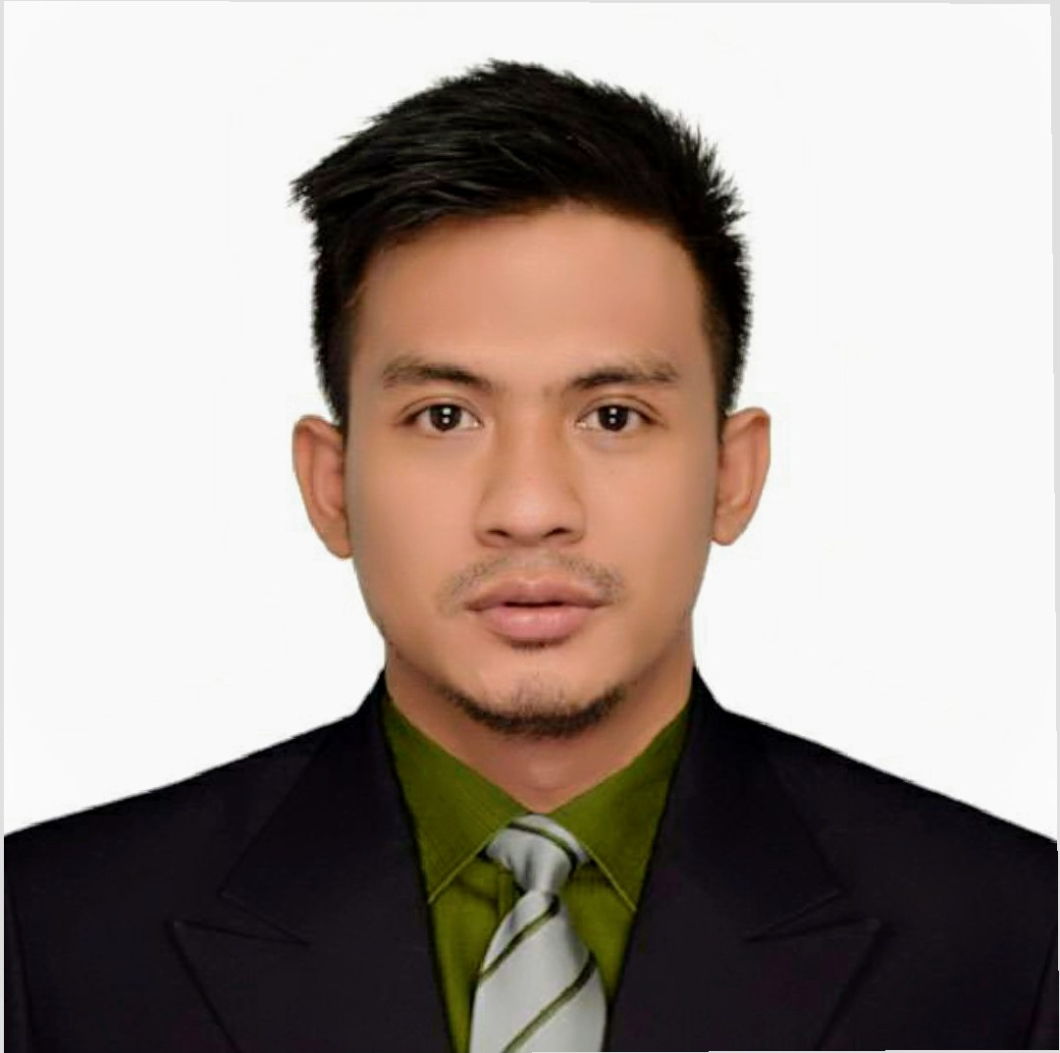
Reymarc Radam Ramos
7203 Al Fallah Othman Bin Affan Road,
Riyadh, Saudi Arabia
mc.rm301994@gmail.com
+966 571 187 646

PROFESSIONAL SUMMARY

Multi-faceted, efficient, and reliable worker with 5+ years of experience supporting business operations, back of the house, sales personnel, and managers to improve internal and external operations for businesses.

WORK EXPERIENCE

Retail Store Supervisor Jan 2021 - Present
Serbal Trading Corporation • Riyadh, Saudi Arabia

- Establish work schedules and supervise crews
- Supervise and Coordinating activities of workers
- Coordinating with the staff to sell merchandises and promotions
- Assign sales workers to duties
- Ensuring Good Customer Service
- Ensuring Quality of merchandise received
- Ensuring of training and Quality of Service
- Supervise and check delivery
- Prepare and submit reports on sales volumes and merchandise
- Maintain records of stock, repairs, sales and wastages
- Estimating merchandise to be ordered
- Oversees store operations

Office Staff Sep 2018 - Sep 2019
Monol International Education Institutes • BAGUIO CITY (BENGUET), Philippines

- Prepare correspondence, reports, statements, forms, presentations, applications and other documents from notes
- Respond to telephone, in person or electronic enquiries or forward to appropriate person
- Provide general information to staff, students and the public regarding company or program rules, regulations and procedures
- Photocopy and collate documents for distribution, mailing and filing
- Sort and file documents according to established filing systems, locate and retrieve documents from files as requested and maintain records of filed and removed materials
- Maintain and prepare reports from manual or electronic files, inventories, mailing lists and databases
- Process incoming and outgoing mail, manually or electronically
- Send and receive messages and documents using fax machine or electronic mail
- Maintain inventory of office supplies, order supplies as required and arrange for servicing of office equipment
- May perform basic bookkeeping tasks such as preparing invoices and bank deposits
- May sort, process and verify receipts, expenditures, forms and other documents
- May organize the flow of work for other office support workers.

Restaurant Team Leader Nov 2015 - Jul 2019
Can Cafe • Riyadh, Saudi Arabia

- Managing restaurant staff's work schedules.
- Conducting regular inspections of the restaurant kitchen to determine whether proper standards of hygiene and sanitation are maintained.
- Overseeing food preparation, presentation, and storage to ensure compliance with food health and safety regulations.
- Checking in on dining customers to enquire about food quality and service.
- Monitoring inventory and ensuring that all food supplies and other restaurant essentials are adequately stocked.
- Monitoring the restaurant’s cash flow and settling outstanding bills.
- Provide a high level of customer service and quality work performance.
- Direct Report any problem to Shift Supervisor or Shift Assistant Manager of Operation with dotted line responsibility to Restaurant Area Manager Supervision to the Service Team to include training, attendance and performance management.
- Assist the Shift Supervisor/Area Manager in ensuring the day by day operations of the Café. Opening and Closing duties as assigned by Manager.
- Reviewing customer surveys to develop and implement ways to improve customer service.
- Resolving customer complaints in a professional manner.

Travel Agent Aug 2014 - Nov 2015
Carnation Travel and Tours • Manila, Philippines

- Provide travel information to clients regarding destinations, transportation and accommodation options and travel costs, and recommend suitable products
- Plan and organize vacation travel for individuals or groups
- Make transportation and accommodation reservations using computerized reservation and ticketing system
- Sell single fare tickets and package tours to clients
- Promote particular destinations, tour packages and other travel services
- Provide travel tips regarding tourist attractions, foreign currency, customs, languages and travel safety.

EDUCATION

Bachelor of Science in Tourism Management Jun 2010 - Apr 2014
ABE INTERNATIONAL BUSINESS COLLEGE AND ACCOUNTANCY • Urdaneta city

SKILLS AND QUALITIES

- Effective interpersonal skills
- Flexibility
- Team player
- Excellent oral communication
- Client focused
- Inventories
- Warehousing
- Dependable
- Reliable

VOLUNTEER WORK

Social Worker Apr 2014 - Jul 2014
Brgy. Carosucan Norte Barangay Hall • Asingan, Pangasinan, Philippines

- Assisting communities in receiving services by telephone and in person.
- Getting communities involved in beneficial activities.
- Assessing communities and gathering relevant information.
- Offering information and supporting families.
- Contacting and making referrals to other agencies and services.
- Maintaining accurate records and preparing reports.
- Participating in training, supervision, and meetings.
- Provide crisis intervention.

AWARDS AND HONOURS

Commendation of Good Customer Service Award 2015

