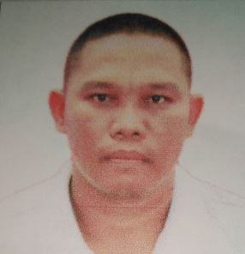YGAÑA,RIO JABUTAY
Zone 5 Luyong Bonbon,Opol
Misamis Oriental
Mobile No. 0906-897-6042
_________________________________________________________________________________
PROFILE
Exemptional skills, an ability to take direction well, can work under pressure and juggle multiple tasks and meticulous attention to details, makes my section a vital part of the company. As I may alleviates the pressure off to superiors by completing tasks assigned in a timely manner.
I am a dynamic, passionate and highly efficient trailer driver who is a self-starter, who can anticipate the needs of the company.
OBJECTIVE
To have relevant and challenging position when I can impart my knowledge and be an asset to the Company.
WORK APTITUDE
- Driving License Restriction Code 1-2-3-8
- Able to work as a Welder and under chassis Welder
PERSONAL INFORMATION
Age : 41 years old
Date of Birth : February 20, 1979
Nationality : Filipino
Gender : Male
Civil Status : Single
Height : 5’6”
Weight : 80 kls.
Religion : I.F.I
Father’s Name : Romeo P. Ygaña
Mother’s Name : Merlyn J. Ygaña

EDUCATION
- Graduate, Secondary Education– Opol National Technical School- Opol, Misamis Oriental, 1996
- Graduate, Elementary Education– Luyong Bonbon Elementary School- Luyong Bonbon,
Opol, Misamis Oriental, 1991

TRAINING AND SEMINAR ATTENDED
MAN Truck – March 21 2012
HPG10 Traffic Safety and Driving Techniques – August 4, 2017

WORK EXPERIENCES
June 2017- Present
Trailer Tanker Driver- MC Shipping Corp.
Nahalinan Jasaan, Misamis Oriental

June 2010- May 2017
Trailer Driver-Top Kick Movers
El Salvador City

June 2008- May 2010
Trailer Driver- Al-Jaber Transport and Heavy Equipment
Doha-Qatar, Al Khor

REFERENCES
- Ms. Anita M. Florenosos
Admin Officer/ Accounting Officer- Mc Shipping Corporation
OTHER REFERENCES
- Available on request

