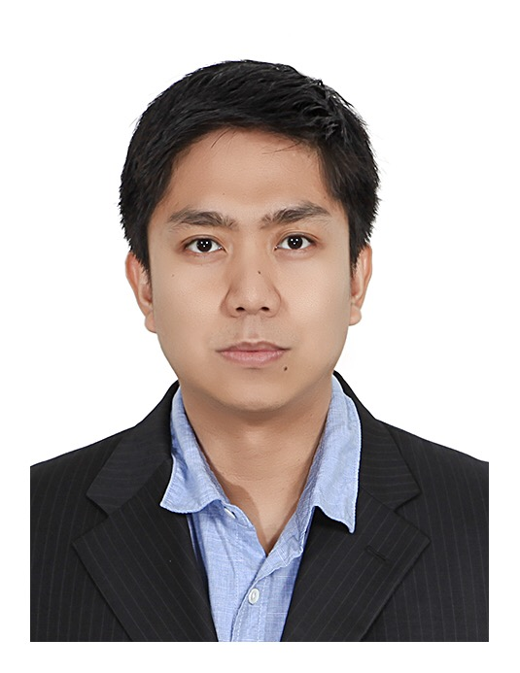
MENESES, Samuel B.

E-mail: engrsbm@gmail.com

Contact No. +82-10-6414-5440

PROFESSIONAL PROFILE
Fast learner and dedicated to work as an Engineer with 10 years of experience. Seeking for a better opportunity to grow as an individual and as a Professional with proven skills and can adapt to different work environment.

PROFESSIONAL EXPERIENCE

Daewoo Engineering & Construction Co., Ltd.
Seoul, South Korea
Proposal Engineer at Headquarters (2013-present)
- Responsible for preparation of Technical Proposal (TP)
- Understanding of the Instructions to Bidders (ITB)
- Familiarization with the Draft Contract
- Preparation of Distribution of Responsibility (DOR)
- Coordination of the Technical Proposal input to other Department
- Writing of correspondence email to Client or other relevant personnel for the TP
- Prepared Technical Proposals of the following awarded Daewoo E&C Projects:
  - Demolition of MOF 2 General Cargo Berth, Nigeria
  - S-OIL SPM2 Project, Korea
  - NLNG HEX Replacement, Nigeria
  - Mozambique LNG Trains Project, Mozambique
  - KNPC NRP 2&3 Project, Kuwait
- Application of Aspentech Capital Cost Estimation (ACCE) Class IV estimation
- Support for Temporary Facilities Drawing using Autocad

Air Liquide Philippines Incorporation
Clark, Pampangga Philippines
Process Engineer (2011-2013)
- On-site operations of an Air Separation Unit to supply Nitrogen to Texas Instruments
- Start-up and shut-down of Plant
- Daily monitoring of equipment parameters
- Proper response to alarms and critical scenarios
- Mastery of Distributed Control System (DCS)
- Achieved Health and Safety Trainings such as but not limited to:
  - Fire Fighting
  - Confined Space
  - Proper Protective Equipment
  - Cryogenic Safety
  - Self-contained breathing apparatus (SCABA) training
  - Safety driving
- Mastery of the Plant Equipment such as:
  - Centrifugal Air Compressors
  - Refrigeration Unit
  - Mole Sieve Unit
  - Cryogenic Distillation Unit
  - Cryogenic Storage Tanks
  - Cooling Water Tower

SMART Communications, Inc.
Tarlac City, Philippines
Intern (2009-2010)
- Network Platform Services Division
- Network Service Assurance Subscriber
- Network Connectivity.

CORE COMPETENCIES
- Technical Proposal Write-ups
- Aspen Capital Cost Estimation
- Electronics Engineering Background
- Plant Operations (DCS, SCADA)
- Autocad Knowledgable
- Primavera P6 Knowledgable

EDUCATIONAL ATTAINMENT
- Bachelor of Science in Electronics Engineering
- Tarlac State University, Philippines (2005 – 2010)
- University of the Philippines (2003-2005)

CERTIFICATIONS/ SEMINARS
- Philippines Professional Regulation Commission Board of Electronic Engineering License ( Registration Number:0046522)
- ASPEN Capital Cost Estimator Phase 1 Conceptual Estimating
Seoul, South Korea, May-June 2016
- Basic MS Project Training
Daewoo Engineering and Construction Seoul, South Korea, September 2014
- Fire Fighting and Control Training
Air Liquide Philippines Incorporation Pasig Plant, March 16, 2012
- Field Programmable Gate Array (FPGA) Workshop
Engineering AVR, Tarlac State University, February 28 – March 1, 2010
- Zigbee Technology
Engineering AVR, Tarlac State University, February 13, 2009
- MICROELECTRONICS and FPGA
Engineering AVR, Tarlac State University, February 6, 2009

ORGANIZATIONS
- Institute of Electronics & Communications Engineers of the Philippines Inc. (IECEP)
- Boy Scouts of the Philippines – Eagle Scout Rank

PERSONAL INFORMATION
- Date of birth: May 1, 1986
- Place of birth: Tarlac, Philippines
- Height: 170 cm. (5’7”)
- Weight: 70 kg. (154 lbs)
- Languages: Filipino, English, Korean (basic)

CHARACTER REFERENCE:
- Waldo Sapla
Daewoo Engineering & Construction
Engineer
+82-2288-3342

- William Pasamonte
Daewoo Engineering & Construction
Engineer
+82-2288-5040

- Melvin Mercado
Daewoo Engineering & Construction
Engineer
+82-2288-2938

I hereby certify that the above information is true and correct.


Samuel Meneses
Engineer

