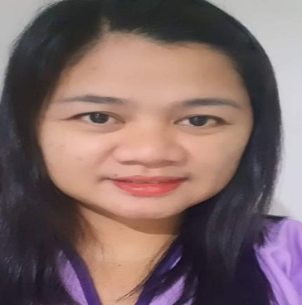
JANE T. VILLEGAS
Registered X-ray Technologist
Licence no. 0007313
Gmail: janevil1976@gmail.com
CP no. 0950-4590-906

Objectives:
To search for a responsible and a demand position that will use my skills and knowledge in a medical field by associating with the developing Institution.

Skills :
Along with learning about the technology and equipment required to be successful, a radiologic technologist will also learn a good deal about examination methods, human anatomy, safety around radiation protection, and more about the basics of caring for patients.
A successful radiologic technologist will be comfortable with the human body and interacting physically with patients and confident in their ability to position patients accurately on the table in order to use radiation as safely as possible.
- Applying radio-opaque contrast media solutions
- Assessing bone density
- Developing radiographic images
- Hysterosalpingogram procedures
- Knowledge of anatomy
- Positioning patients
- Practicing sterile techniques
- Reviewing images for quality
- Strictly following radiology safety protocols
- Taking X-rays of various body parts
- ECG procedure

Professional Experience:
Sacred Heart Medical And Diagnostic Clinic
Maga Bldg. Magallanes Village
Makati City
January 3, 2022- up to Present

Gold Medicheck Inc.
Sen. Gil Puyat Cor. Taft Avenue Pasay City
From : 20 October 2020 up to August 3 2021

ABDUL-RAHMAN AL-SAHLY MEDICAL CENTER
Jeddah , Kingdom of Saudi Arabia
From : 12 October 2013 – 08 December 2015
Length of service : 2yrs.
Reason of leaving : Finish contract

EBIN SINA MEDICAL CLINIC
Taif , Kingdom of Saudi Arabia
From : May 2004 to November 2012
Length of service : 8 yrs.
Reason of leaving : Finish contract

QUANTA COMPUTER COMPANY
Tayouen, Taiwan R.O.C.
Computer Assembly / Computer Technician
From: March 2000 to February 2003
length of service : 3yrs.
Reason of leaving : finish contract

ST. VINCENT HOSPITAL
Concepcion Marikina City
From: 1998 February – 2000 January

EDUCATIONAL ATTAINMENT :
College :
EMILIO AGUINALDO COLLEGE
Associate in Radiologic Technology
Secondary:
Arellano Plaridel High School
Primary :
Balogo West Elementary School

Reference :
Florive Mimis
Head Nurse
Gold Medicheck
Pasay city

Mylene Sanchez
Dental Technician
Zir-Con Laboratory
Cabuyao, Laguna

Melissa Anne Reynon
Call Center Agent
Skykes Company
Mandaluyong City

Personal Data:
Address : #51 Paquita St. Brgy. 127 M. Dela Cruz Pasay City
Birthdate : January 9,1976
Age : 45 Y/O
Civil status : Single
Cellphone No: TNT # 095-0459-0906
Globe : 0945-3213-486

Jane T. Villegas
Registred x--ray Technologist

