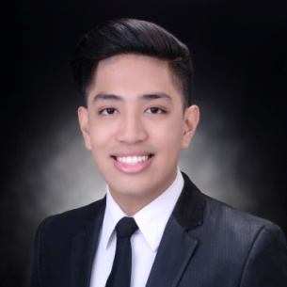
EDUARDO REYES PRIMA, JR.
Address: 28-B, Bansalangin St., Veterans Village, Project 7, Quezon City
Phone: 09163219338
E-mail: erpj1028@gmail.com

BACHELOR OF SCIENCE IN TOURISM MANAGEMENT

Career Objective
Highly dependable and motivated graduate looking to contribute to the success of the company; to hone my skills and abilities; to achieve organizational and personal goals as well.

Education
Bachelor of Science in Tourism Management (2013-2017)
Far Eastern University
Sampaloc, Manila

Pre-Professional Experience
Student Trainee – Events Management NCIII (March 2016)
Student Trainee – Front Office NCII (March 2016)
Intern – 7107 Islands Management, Inc. (April-June 2015)
Student Exchange Participant – Kahler Apache – Housekeeping (April-July 2016)

Seminars
Attendee, Philippine Travel Mart 2015 – SMX Convention Center, Mall of Asia – September 4-6, 2015
Attendee, Pinoy Chika 2nd Edition Sports, Adventure and Wellness Tourism- SMX Convention Center,
Mall of Asia – July 22, 2015
Attendee, Career Talk on Cruise and Hotel Industry – March 05, 2015
Attendee, Macro Asia Industry Familiarization Tour – Macro Asia – September 20, 2013
Attendee, World Tourism Day, Far Eastern University – September 26, 2014

Skills
- Interpersonal Skills
- Good Communication Skills
- Adaptability
- English Proficiency
- Computer Skills
- Customer Service Skills
- Time Management

