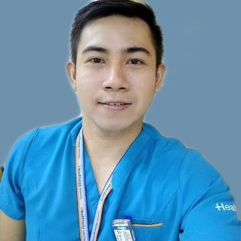
MARVIN G. BRIONES RRT,RSO
Licensed Saudi Radiology Specialist
Radiation Safety Officer Certified
Address: Baybayog,Alcala ,Cagayan
Email Address: rambriones29@gmail.com
Mobile number: 09567730187

CAREER OBJECTIVE:
To apply my acquired knowledge and skills from various professional experiences to a new working environment giving new insights and quality service to my patients, co-medical workers, the company and to all stakeholders

CAREER HISTORY:

UNLab Medical Corporation
Ermita ,Manila
July 2021 up to present

Nas Hr Solutions
Riyadh ,Kingdom of Saudi Arabia
March 25 2019 to March 24 2021

Mother and Child General Hospital
Olongapo City, Philippines
November 2018 to March 2019

Healthway Medical International Inc.
Makati City, Philippines
August 2016 to June 2018

Supercare Medical Services Clinic
Manila, Philippines
March 2016 to July 2016

Provincial Health Office
Capitol Hills, Tuguegarao City, Philippines
October 4 2012 to March 2015

Dr. Ronald P. Guzman Medical Center
Capitol Hills, Tuguegarao City, Philippines
April 2010 to October 2012

Er plus medical and surgical clinic
Balic Balic Quiapo
January to November 2010

TRAININGS AND SEMINARS ATTENDED :

- A glimpse inside diagnostic imaging clinical practice & emergency response
Our Lady of Guadalupe Colleges via Google meet
December 18, 2021

- Resilience amidst COVID-19 pandemic
Philippine Children’s Medical Center, Manila
November 13, 2021

- Future is here: Radiologic Technology as a profession
Emilio Aguinaldo College ,Manila
Nov 8, 2021

- Quality Image -Quality Care
Metro Subic Colleges, Olongapo City
November 24, 2018

- Radiation Safety Officer training course
TUV Rheinland Philippines, Makati
February 9, 2017

- Key to professional advancement
Teachers Camp , Baguio City
December 1, 2012

- National Disaster Preparedness and Awareness
Dr. Ronald P. Guzman Medical Center
Tuguegarao City, Cagayan
July 19, 2021

SKILLS:

Microsoft office , general diagnostic imaging , fluoroscopy exams , patient tracking , digital radiography, computed radiography, computed radiography, tomography, mobile radiography

EDDUCATIONAL BACKGROUND AND ACQUIRED LICENSES:

Bachelor of Science in Radiologic Technology
Medical Colleges of Northern Philippines
2005 - 2009

Licensure Examination for Radiologic Technologist
Passed March 2009
Lic : 0007805

Saudi Commission for Health Specialties
Passed October 02, 2021
ID Number P6132250A
Rank: Specialist Technologist

Department of Health
Bureau of Health Device And Technology
Training Course on Radiation Protection for Radiation Officers
October 9-11, 2017

PERSONAL BACKGROUND:

Date of Birth: February 14, 1989
Height: 5’9”
Weight: 170 lbs
Nationality: Filipino
Civil status: Single

I certify that the above information is true and correct to the best of my knowledge.

MARVIN G. BRIONES, RRT
Applicant

