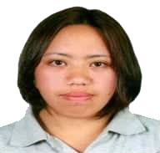
LANIE L. LIBANG
Balili, Mankayan, Benguet Philippines
09707121482
e-mail:libanglanie104@gmail.com

PERSONAL DETAILS:
Date of Birth: August 6, 1992
Place of Birth: Bauko,Mt. Province
Gender: Female
Age: 29
Nationality/ Religion: Filipino/Christian
EDUCATIONAL BACKGROUND
TERTIARY:
BSBT COLLEGE,434 Magsaysay Ave.Baguio City
2014-2015
SECONDARY:
Balili National High School, Balili, Mankayan, Benguet
2009-2010
ELEMENTARY:
Balili Elementary School, Balili, Mankayan, Benguet
2005-2006
EXPERIENCE AND SKILLS
Cultivation Agriculture
Address:Mikawa Tachiarai Machi Mii-gun Fukuoka Ken Japan
Date: December 2018-December 2021
- Land preparation (Tilling soil and applying fertilizers)
- Seedling establishment
- Planting
- Harvesting
I certify that the above information is true and correct at the best of my knowledge.
LANIE L. LIBANG
Applicant

