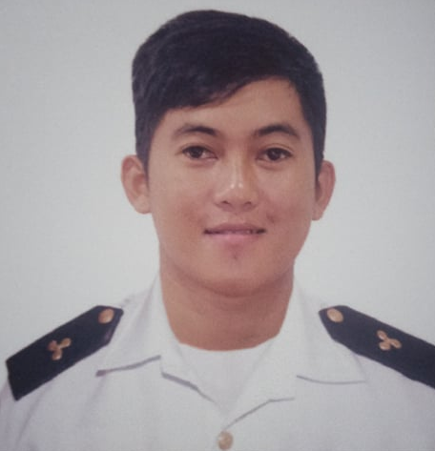
JOHN RONAND C. FLORES
Sabang Danao City Cebu
0923-118-0813

OBJECTIVE:
An eagerness to learn and to work professionally with a high degree od dedication and involvement in achieving the aims and goods for the establishment.

PERSONAL PROFILE

Birthday : December 03, 1994
Age : 27
Religion : Roman Catholic
Gender : Male
Weight : 65 kg.
Height : 5’6
Civil Status : Single
Father’s Name : Aquino N. Flores
Occupation : Driver
Mother’s Name : Charmie C. Flores
Occupation : Housewife

EDUCATIONAL PROFILE

Tertiary : Cebu Technological University
Course :BS Marine Engineering.
. 2013-2014

Secondary : Sabang National High School 2010-2011

Primary : Sabang Elementary School
2006-2007

EMPLOYMENT HISTORY
March 2017 – August 2017
SM SAVEMORE
STOCK CLERK

January 15 2018 – January 16 2019 KHERI LINES INC.
APPRENTICE ENGINEER

March 2019 – September 2019 MONDE NISSIN
PRODUCTION OPERATOR

April 2021 – October 2021
Asian Shipping Corp.
Wiper

KEY STRENGTH AND COMPETENCIES

- Good Interpersonal Skill
- Willing to do overtime job
- Willing to learn new things
- Hardworking

CHARACTER REFERENCES

Rhogimy Tero
Merchandiser
Binaliw, Danao City
0975-672-1875

James Albert Cahigas
C.I ( DUEK SAM )
Sabang, Danao City
0905-528-8535

Ruel Reloba
Ordinary Seaman
0965-108-5512

I hereby certify that the above information is true and correct to the best of my knowledge.

JOHN RONAND C. FLORES
Applicant

