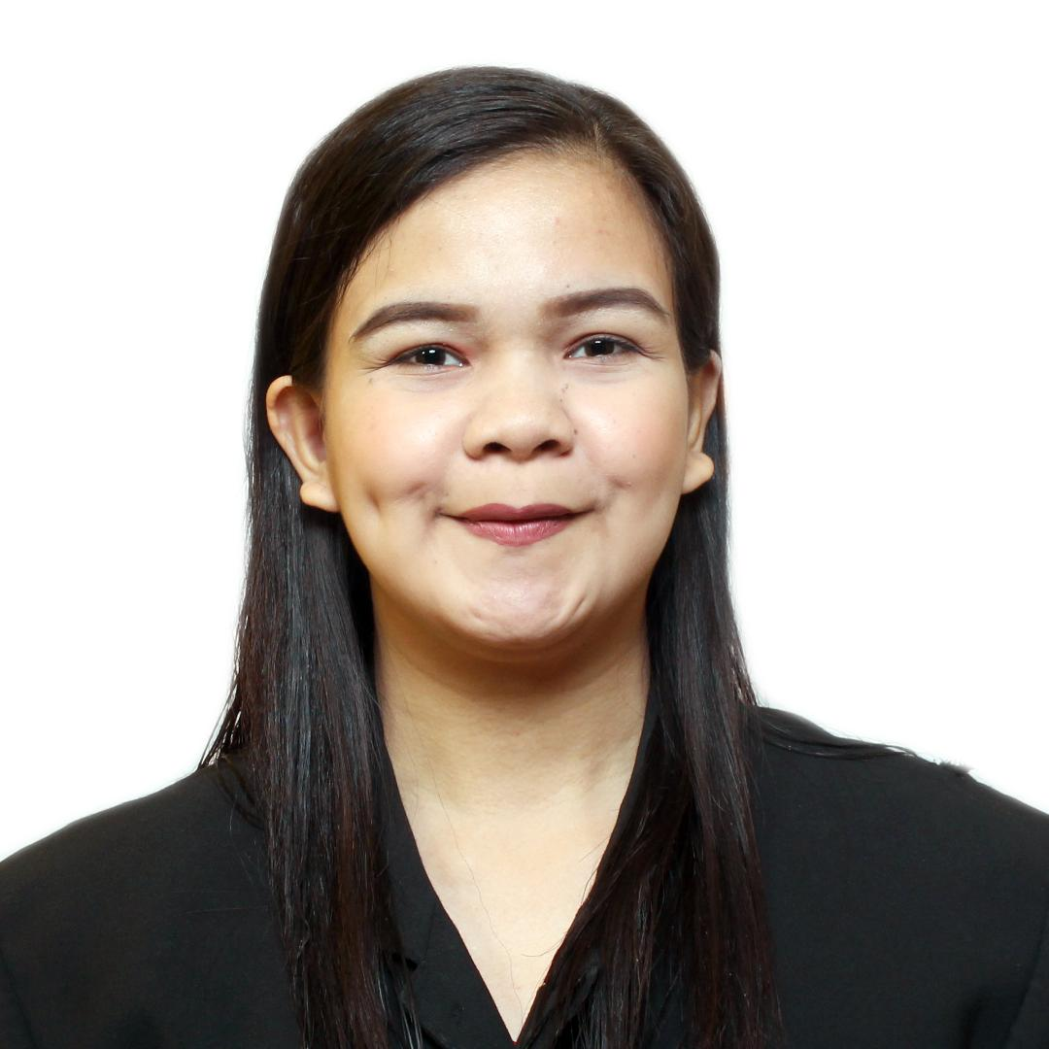
ANDREA MAE C. LAGO
#193 Zone 2 Brgy.Hall, Patag, Cagayan de Oro City, Misamis Oriental, 9000
andreamaecalamba@yahoo.com
0995-167-1730

WORK EXPERIENCE

Medical Representative
PHILCARE PHARMA INC.
#3 Mahogany St., Brgy Santolan, Pasig City
(January 2020- January 2021)

Elementary Teacher, Grade 2 and Grade 4
SUMMER HILL SCHOOL INC
Patag, Cagayan de Oro City

Intern, Grade 4 Student Teacher
Liceo de Cagayan University -
Basic Education Department
Carmen, Cagayan de Oro City

Volunteer Teacher Aide, Community Service
GUGMA SA KABATAAN Foundation
Brgy. Consolacion, Cagayan de Oro City

EDUCATIONAL ATTAINMENT
Graduated, Bachelor of Elementary Education Major in Special Education
Liceo de Cagayan University,
Rodolfo N. Pelaez Blvd., Kauswagan,
Cagayan de Oro City
March 23,2018

AWARDS RECEIVED
3RD Runner Up, Philcare Pharma Detailing Contest
May 2020, Pasig City
Dean’s Lister, Liceo de Cagayan University. Cagayan de Oro City.(SY 2014- 2015)

SKILLS

- Leadership Skills
- Communication Skills - (Mass, Inter, and Intra), and
- Computer Literate (Microsoft MS Word, MS Excel, MS Power Point)

- Driving Skills
- Teaching Skills
- Handle Irregular and Regular Students

SEMINARS AND TRAININGS ATTENDED
Training for Medical Representative
PHILCARE PHARMA INC.
Pasig City

Personality Development Seminar
Avr 1,Liceo de Cagayan University
RN Pelaez Blvd., Carmen, Cagayan de Oro City

Communicating with Parents; Interactive Motivational Strategies. Liceo de Cagayan University
RN Pelaez Blvd., Carmen, Cagayan de Oro City

Differentiating Instructions and Assessments; Guide to Effective
Learning Plan
Liceo de Cagayan University
RN Pelaez Blvd., Carmen, Cagayan de Oro City

Engaging Effective Classroom Management and Psychology of
Learners in the 21ST Century
Liceo de Cagayan University
RN Pelaez Blvd., Carmen, Cagayan de Oro City

