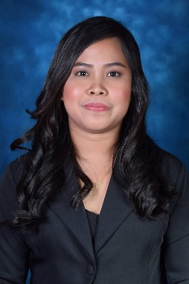
ROSANNA JANE REYES BALMORES
+639617908125
Balmoresrjane16@gmail.com
San Fermin Cauayan City Isabela

Objectives
I am looking for a job where I could practice my knowledge and developed my personality as a career person while utilizing my skills.
PERSONAL DETAIL
Nickname: Rjane
Birth Date: July 16, 1997
Age: 24
Civil Status: Single
Language: Tagalog, Ilokano, English
Nationality: Filipino
Height: 5’
Weight: 55kgs.

Education Background
Tertiary: Our Lady of Pillar College-Cauayan 2014-2019
Bachelor of Science in Computer Engineering
San Fermin Cauayan City Isabela

Skills
- Can adopt work easily
- Can work long hours
- Ability to work independently or as part of team
- Computer skills; MS Word, PowerPoint
EXPERIENCE
- Universal Leaf Philippines Inc. (Accounting Assistant)
July 2021- November 2021
- Aeon Credit Philippines (Sales promoter)
October 2019- March 2020
CHARACTER REFERENCES
- Engr. Maxwell Cabulagan
College Teacher at Our Lady of the Pillar Collge-Cauayan
Phone Number: +639161046110
- Evangeline Sarte Ph.D.
College Dean at Our Lady of the Pillar College-Cauayan
Phone Number: +639771428981
I hereby certify that the above information is true and correct to the best of my knowledge and belief.

ROSANNA JANE REYES BALMORES

APPLICANT

