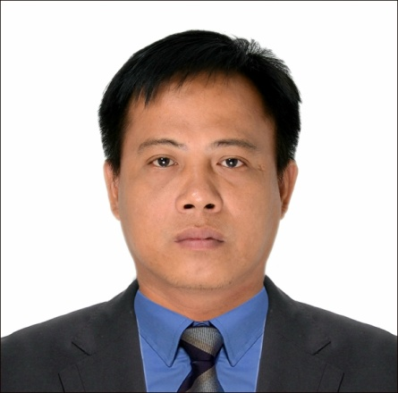
ROWEL C. ESCORPIZO
CIVIL ENGINEER
AGE:37 YEARS OLD
Contact number: +639453396680/09612991958
Email address: rowele123757@yahoo.com
PRC License number: 0123757

OBJECTIVE: Seeking for a job that gives me opportunities to learn, innovate and enhance my skills and strengths in conjunction with company goals and objectives.
SKILLS
- Excellent project management
- AutoCAD operation 2d
- Able to operate Microsoft office such as WORD, POWERPOINT, EXCEL
- Efficient management and organization skills
- Excellent in critical thinking and evaluation abilities
- Knowledge on project design and analysis
WORKING EXPERIENCE
- Project in charge – El eloha Construction: Earthworks and road construction
DECA HOMES, Margot, Clark, Pampanga (November 2012-May 2013)
JOB DESCRIPTION:
- Strict supervision and delegation of work for all workers, laborers, operators, and drivers on site.
- Scheduling of daily task for all workforce
- Attending of weekly coordination meeting
- Weekly progress report
- Preparation of weekly schedule
- Preparation of request materials and shop drawings

- Project Engineer- New Bilrey Construction And Development Corporation: earth works, roads construction, residential building construction.
#94 Aramismis St., Veterans Village, Project 7, Quezon City
AFP/PNP HOUSING PROJECT- BRGY San Luis, Pugo, La Union( June 2013-December 2015)

JOB DESCRIPTION:
- Coordinates the proper interpretation of technical plans and specifications
- Coordinates project requirements as to manpower, materials, equipment and finances to all concern units
- Oversees and evaluate project status and recommends corrective action and control measures for proper timely accomplishment of the project
- Schedule and plans of all actual construction and related works and coordinate with the project design engineer or consultants
- Supervised the payment of materials and accomplishment
- Perform task in accordance with processes defined in the company safety and quality standards
- Civil site Engineer-Oriental Construction company Weavers (November 2016- November 2018)
Jeddah Saudi Arabia
JOB DESCRIPTION:
- Monitoring project status, and proper installation of materials as per plan
- Daily accomplishment report
- Supervision and implementation of project
- Estimate and request materials needed on the site
- Project Engineer -CYBERAGE CONSTRUCTION CORPORATION (MARCH 2019-PRESENT)
HEIP -HERMOSA, BATAAN
PUEBLO DE ORO MALVAR BATANGAS

JOB DESCRIPTION:

- ESTIMATE quantity of the project prior for bid preparation
- Weekly progress report
- Preparation of billings
- Manpower supervision and equipment monitoring
- Attending weekly coordination meeting with the client

EDUCATIONAL ATTAINMENT
COLLEGE : University of Baguio
General Luna Road, Baguio City
Bachelor of Science in Civil Engineering
(November 2011)

SECONDARY : Callang National Highschool
District 4, San Manuel, Isabela
(March 2001)

ELEMENTARY : Teofilo Gante Elementary School
Sanchez, Asingan, Pangasinan
(March 1996)

CHARACTER REFERENCE
Engr. Michbah al Alewi
Project Engineer OCC weavers
+9660541419549
Engr. Gianno Lalap
ILMI PROJECT CONSULTANT PUEBLO DE ORO
09219938546
ENGR. RONALD CRUZ
PROJECT ENGINEER CYBERAGE CONSTRUCTION
09564607253

I hereby certify that the above information are true and correct, to the best of my knowledge and belief.
ENGR. ROWEL C. ESCORPIZO
CIVIL ENGINEER

