Macavinta , Benson Stevens Alorro

Email: bsmacavinta@yahoo.com

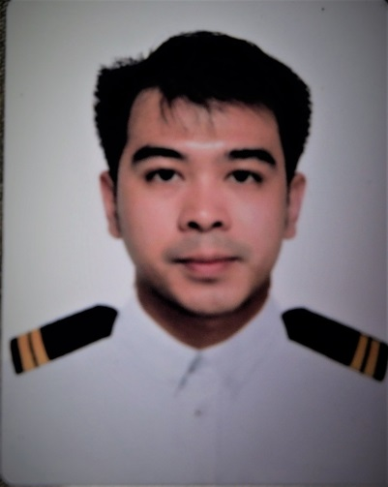

JOB OBJECTIVE:
To be qualified as a dynamic, innovative and experienced Electro Technical Officer/ Electrical Engineer making use of my expertise, skills, talents and abilities to troubleshoot electrical, refrigeration, pneumatic and hydraulic systems, and other automations.

CAREER ELIGIBILTY:
April 2012 Board Passer, Philippine Licensure Exam for Registered Electrical Engineer.

ACADEMIC
BACKGROUND:

Good Shepherd School
Early Childhood Education, 1994-1998
San Jose, Antique

Delegate Angel Salazar Memorial School
Grade School Department
Elementary Education, 1998-2002
San Jose, Antique

ST. ANTHONY’S COLLEGE
High School Department
Secondary Education, 2002-2006
San Angel, San Jose Antique

CENTRAL PHILIPPINE UNIVERSITY
College of Engineering
Bachelor in Science of Electrical Engineering), 2006-2011
Jaro, Iloilo City

EXPERIENCES AND
ACCOMPLISHMENTS:

- Elect Cadet, Vessel : M/V VEGA AURIGA
Type: Container
KW/HP: 9600
GRT: 9981
Sign-On date: 06 Jul 2013
Sign-Off date: 18 Mar 2014
Route: World wide

- Elect Officer, Vessel : M/V VEGA LUNA
Type: Container
KW/HP: 13048
GRT: 9940
Sign-On date: 05 Jul 2014
Sign-Off date: 21 Mar 2015
Route: World wide

- Elect Officer, Vessel : M/V VEGA OMIKRON
Type: Container
KW/HP: 9600
GRT: 9981
Sign-On date: 24 Aprl 2016
Sign-Off date: 19 Dec 2016
Route: World wide

- Elect Officer, Vessel : MV ALM ZURICH
Type: Container
KW/HP: 55890
GRT: 54,214
Sign-On date: 18 Jul 2017
Sign-Off date: 4 Nov 2017
Route: World wide

- Elect Officer, Vessel : MV ATHINA
Type: BULK CARIER
KW/HP: --
GRT: 40000
Sign-On date: 21 Jun 2018
Sign-Off date: 30 Nov 2018
Route: World wide

- Elect Officer, Vessel : MV Patra
Type: BULK CARIER
KW/HP: --
GRT: 40000
Sign-On date: 9 May 2019
Sign-Off date: 6 Nov 2019
Route: World wide
- Elect Officer, Vessel : MV KAVALA
Type: BULK CARIER
KW/HP: --
GRT: 40000
Sign-On date: 1 AUG 2020
Sign-Off date: 26 JUL 2021
Route: World wide

TRAININGS and
COURSES ATTENDED:

- INTRODUCTION TO MARINE ELECTROTECHNOLOGY. March 18-29 2013
Norwegian Training Center- Manila

- MARINE ELECTROTECHNOLOGY MODULE -2, April 1-5, 2013
Norwegian Training Center- Manila

- ELECTRICAL EQUIPMENT AND SCEMATICS, April 8-19, 2013
Norwegian Training Center- Manila

- CONTROL ENGINEERING MODULE- 1, Apr 22- May 3, 2013
Norwegian Training Center- Manila

- CONTROL ENGINEERING MODULE- 2, May 6-10, 2013
Norwegian Training Center- Manila

- MARINE REFRIGERATION AND AIR CONDITIONING, May 13-17, 2013
Norwegian Training Center-Manila

- INDUSTRIAL ELECTRICIAN, Oct 08-22, 2012
MFI Foundation Incorporated

- REFRIGERATION AND AIR CONDITIONING MECHANIC, Oct 25-Nov 16, 2012
MFI Foundation Incorporated

- ELECTRO-PNEUMATICS, Nov 26-Dec 12, 2012
MFI Foundation Incorporated

- DANGEROUS, HAZARDOUS AND HARMFUL CARGOES, May 20-23, 2013
Far East Maritime Foundation Inc.

- Consolidated MARPOL 73/78 Course, July 23-27, 2012
John B. Lacson Foundation Inc.

- Ship security awareness training and seafarers with designated security duties, May 22, 2014
Excelent and Competency training Center Inc.

- Proficiency in survival craft abd rescue boat, Aug 10-14, 2012
John B. Lacson Foundation Inc.

- BASIC SAFETY TRAINING, July 5-13, 2012
John B. Lacson Foundation Inc.

- Medical Emergency First Aid, Jan 23-27, 2017
Far East Maritime Foundation Inc.

- Advance training in Fire Fighting, Jan 30-Feb 3, 2017
Far East Maritime Foundation Inc.

- Refresher Training for Proficiency in Survival Craft and Rescue Boat other than Fast Rescue Boats, Feb 8-9, 2017
Far East Maritime Foundation Inc.

PERSONAL DATA:

30, Married, Good Moral Character, Hard Working & Patient
Hobbies: Drawing, playing Table tennis, Volley ball, Basketball.

I hereby certify that the above statements are true and correct according to my knowledge.

Macavinta, Benson Stevens A.

