SAMUEL DHAN C. BALBIN
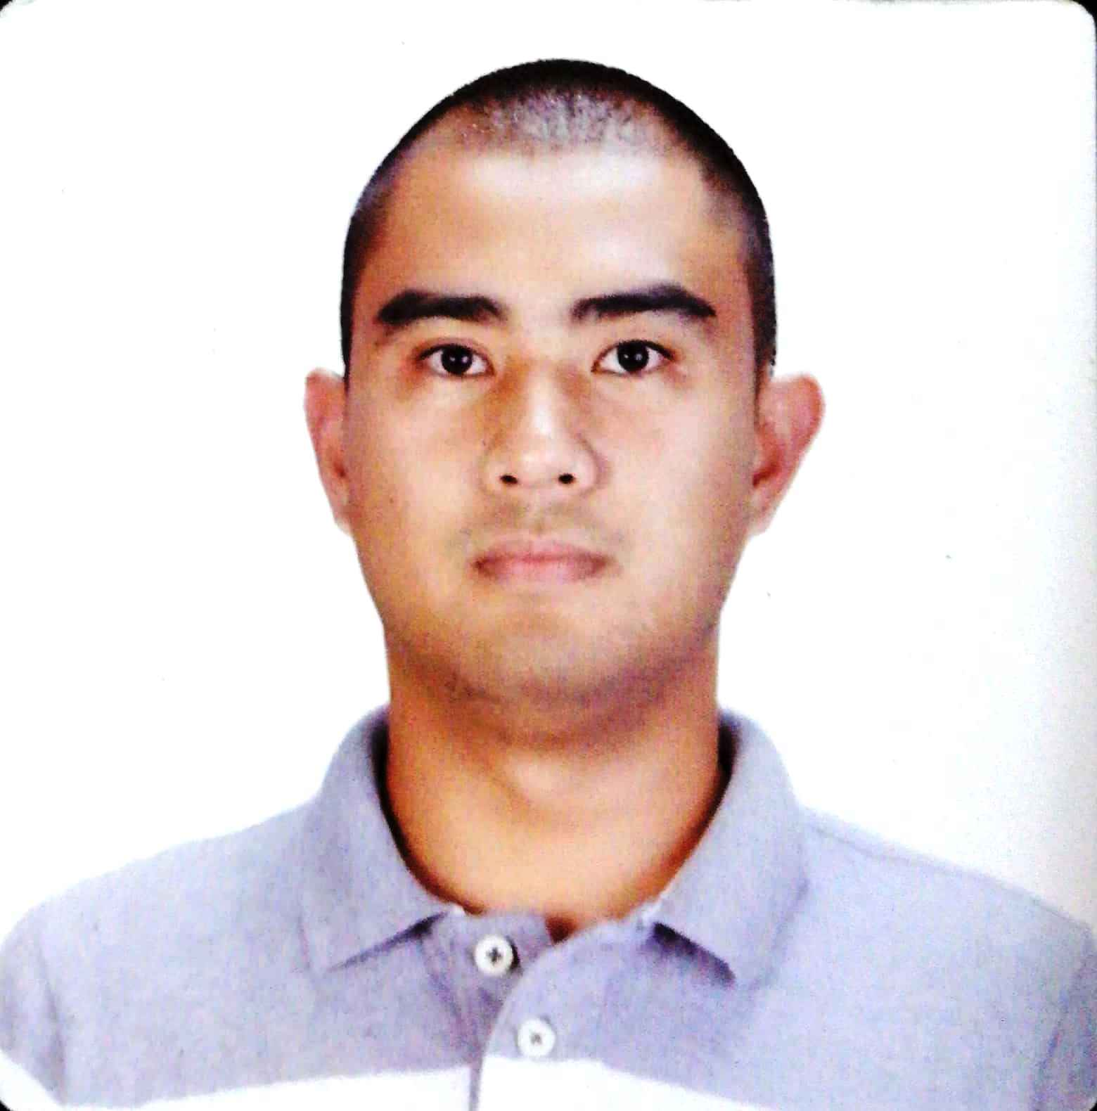

#169-B Pias, Camp 7, Baguio City Philippines
Mobile phone: +63933-865-6882
Email Address: sambalbin01@gmail.com

OBJECTIVES

To build a long-term career as a Machinist where I can fully utilize my trainings, knowledge and skills while making significant contribution to the success of the company.

WORK EXPERIENCE

July 16, 2013 – present MOOG CONTROLS CORPORATION (Philippine Branch)
Machinist III
Honing Operator
- Sunnen SV2115 Vertical Honing Machine (AUTOHONE)
-Doing programming and troubleshooting on this first of its kind machine
-Performs set up and processing parts on this machine
- Sunnen 1804
-Performing prove out on different part number
-Suggestion of tools needed to be used in processing of parts

CNC Mazak Operator (QT 30 model)
- Perform set-up and process parts on these machine
- Read and interpret Blueprint/Sketch Sheet to produce Quality parts

Deburr and I-Lap Operator
- Processing CVC (Check Valve Cell) / Small parts
- Back up deburr operator on CPC (Cylinder Piston Cell) / Large parts
- Processing HOT parts on our work center

EDUCATIONAL BACKGROUND

Master’s Degree Master in Manufacturing Engineering and Management
August 2018 – 2019 Saint Louis University
Baguio City (finished 18 units - Undergrad)

Tertiary Education Bachelor of Science in Mechanical Engineering
June 2007 – March 2012 Saint Louis University
Baguio City, Philippines

Secondary Education Saint Louis High School-Philex
June 2003 – March 2007 Tuba, Benguet, Philippines

Primary Education Philex Mines Elementary School
June 1997 – 2003 Tuba, Benguet Philippines

TRAININGS

February 8- 10, 2018 Canadian Emergency & Risk Management
(40hours) Advanced Firefighting

August 5- 20, 2017 SUNNEN Products Company
Saint Louis, Missouri, United States of America
Machine Run Off (SV2115 Vertical Honing Machine)

April 12- June 17, 2013 MOOG – On-the-Job Training

January 21- March 26, 2013 TESDA Baguio Philippines- Machining NC II

KEY STRENGTHS

- Able to operate Honing machine, including manual and autohone machines, to its proven capability in a highly productive manner
- Basic knowledge on Grinding machines
Conventional Grinding –B&S (Brown and Sharpe)
Studer Grinding Machine –S21 and CT550 (I-Grind)
- Basic ability to operate computer software
- Knowledge in operating CMM machine(Zeiss and Rondcom)
- Basic knowledge and skills in AUTOCAD

ACHIEVEMENTS

October 2012 Mechanical Engineering Exam- Board Passer
(Registered Mechanical Engineer)

PERSONAL DETAILS

Nickname : Sam
Birth date : May 24, 1991
Age : 30 years old
Sex : Male
Civil Status : Married
Nationality : Filipino
Height : 177 cm
Weight : : 88 kgs.
Interests : Playing basketball and biking.

