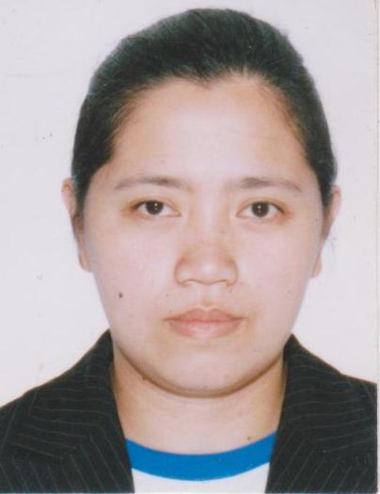
KATHLYN C. AROMIN
Purok 3 Upper Gibraltar Road, Baguio City
Email Address: arominkathlyn0105@gmail.com
Contact No. +639391296260
Any position that I am qualified.
CIVIL SERVICE SUBPROFESSIONAL PASSER

Career Objective:
To continuously update my knowledge, capabilities and skills were I can grow and learn more professionally. Willing to accept challenges and undergo trainings if possible.

Job Description
Operates Modernize Cash Register (POS)
Perform typing and encoding.
Feasible in balancing.

WORKING EXPERIENCE

COMPANY POSITION

SPIL Siliconware Liquid Encapsulation (LE)
February 2011-January 2014
March 2015- March 2018

ASE Semiconductor Die Attach (DA)
June 2000-August 2006

Total Convenient Store Cashier/ Encoder
October 2010- July 2011

Baguio Country Club Cashier / Checker
February 2007-June 2007

Jollibee Session Cashier/ Service Crew
July 1997-February 1998

SPECIAL SKILLS:
Can operate cash registers (POS)
Can do daily and monthly reports , encoding and balancing.
Can operate computerize machine.

EDUCATIONAL BACKGROUND

College University of Baguio
Commerce- Banking and Finance
1994-1998

High School University of Baguio
1990-1994

Elementary University of Baguio
1988-1990

PERSONAL DATA

City Address : Gibraltar Rd., Baguio City
Date of Birth : January 05,1977
Place of Birth : Baguio City
Height : 5’4
Weight : 140 lbs
Religion : Catholic
Civil Status : Married
Spouuse Name : Romeo N. Aroin
Address : Purok 3 Upper Gibraltar Road
Baguio City

