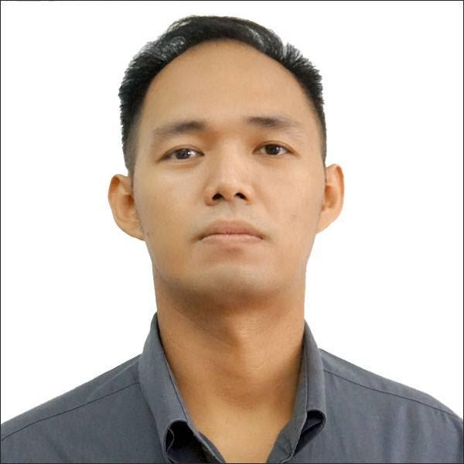
PAPA, JED REINALD S.

24 F. Bautista St. San Francisco Del Monte Quezon City
09664380310(GLOBE)
jedreinaldspapa@gmail.com

- CAREER OBJECTIVE
To be associated in an organization where I can use my knowledge and skills and contribute to the growth of the company for maximum professional development and career growth.
- ACADEMIC INFORMATION

Education
2006 – 2010 FEU – East Asia College BS INFORMATION TECHNOLOGY (UNDERGRAD)
- Working Experience
Service Crew
Wendy’s
SM North, Quezon City
2005 August to January 2006
Job Description
Maintain a fast speed of service, especially during rush times. Maintain cleanliness in the dining area at all times.
Call Center Agent
2019 Nov 5 – Dec 21
Insipiro Q.C Lifetouch Account
We attend to the concerns of customers who are calling like reshipping there order or processed there orders and doing the best we can to give what they want
Frontrow Distributor
2018 – Present Referring people who want to be a distributor
Resell luxxe products
Computer Rental Manager
Managing computer rents 2011 -2018
Service Crew
Wendy’s
SM North, Quezon City
2005 August to January 2006

Job Description
Maintain a fast speed of service, especially during rush times.
GrabFoodRider
Delivering the food from the desired merchant to the pinned location or address
Stock Clerk

Bench
Robinson’s Galleria
2002 September to November
Job Description
Responsible for receiving merchandise, unloading or unpacking it, marking it with codes to be identified, stocking shelves, and helping customers place orders. Works in stores, warehouses, stockrooms, and other storage facilities. May involve heavy lifting.
Character Reference

Felix Jet Silverio
Concentrix
Customer Relations
09172565260

Ian Martin Catabian
Innovative Culinary Creations
Commissary Head
09051439323
______ ______________________
JED REINALD S. PAPA

