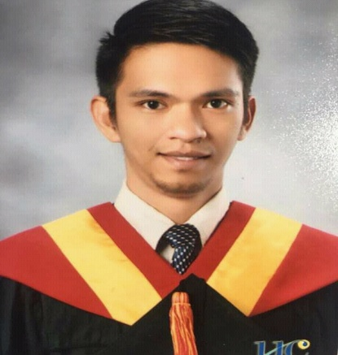

Warren A. Zapanta
296-N Gonzales Compound, Camputhaw, Cebu City
6000, Philippines.
w.zapanta@yahoo.com
+639223619235

Career Objectives:

To obtain attitudes conductive to effective interpersonal relationships and enhance my capacity to deal with problems and learn more about the functional objectives of my career position and that would enhance my abilities and help the company achieve its operational goal.

Working Experience:
ACE Medical Center
Central Supply Staff, March 2021 – Present
- Preparing, storing, and distributing equipment as needed for patient care.
- Oversees proper sterilization of medical supplies.
- Responsible for inventory records of Central Supply Room.

January 2020 – February 2021 unemployed because of pandemic.

MSC PHILIPPINES
Kitchen Utility, May 2018 – Dec. 2019
- Responsible for operating the dishwashing machine and ensure the water temperature is correct.
- Maintain and organize of dishware, smallwares, pots, and pans in storage room.
- Responsible for cleaning the food production areas in the kitchen and restaurant including walls, floors and other areas as necessary.
- Maintain sanitation, health and safety standards in work areas.

Bai Hotel Cebu
In-Room Dining Service, May 2017 - March 2018
- Responsible for preparing orders, set trays.
- Delivering items to guest rooms in attentive and efficient manner.
- Ensuring to provide excellent quality service and memorable experiences as per hotel standards operating procedure.

January 2017 – April 2017 unemployed because I am about to graduate for my bachelor’s degree.

Waterfront Cebu City Hotel and Casino
Waiter / Bartender, June 2015 - December 2016
- Greeting the customer politely.
- Assisted customers needs and wants.
- Giving them recommendation to our best seller food and drink.
- Giving them exceptional customer services and memorable experiences.

GEOPLAN Cebu Foundation, Inc.
On the Job Training (OJT) April 2014 – August 2014
- Front end developer.
- Using the correct background information depend on the clients need and wants.
- User friendly websites.

Skill:
Computer literate.
Adequate skill in table set up.
Good Customer Service.
Service Sequence.
Beginner in Cocktail Mixing.

Hobbies:
Playing Basketball.
Lifting weights in the gym.
Watching movies.
Adventure.

Training:
- Restaurant Server/Bus, May 2017 – October 2017

Educational Background:

College Level: Bachelor of Science in Computer Engineering
University of Cebu (main campus), March 2017 (graduate).

Character References:
Ms. Narissa L. Lopez
CSR Supervisor
ACE Medical Center
+639501298857

Ms. Jazel Anne M. Villegas
Site Manager
Teleperformance
+63932 444 0268 / +63917 831 4141

