
JEREMI D. MARCOS
246 Herrera St.
Brgy. 28 San Bernabe, Laoag City
Ilocos Norte, 2900
Mobille Number: 09672378529
Email Address: jeremimarcos.jm@gmail.com
Career Objective:
Enthusiast person with a strong commitment to the work given for the development of my personal and professional growth. I have a excellent communication skills that interacts to the the staff, employees, and other personal in the company. I will utilize the experience to enhance my knowledge to the best of my capability paving more opportunities for advancement.

Personal Data

Sex: Male
Age: 23
Date of birth: September 1, 1998
Place of birth: Laoag City, Ilocos Norte
Civil status: Single
Citizenship: Filipino
Height: 5’5”
Weight: 67 kgs.
Religion: Roman Catholic
Language Spoken: Ilokano, English, Filipino
Father’s Name: Victor C. Marcos
Mother’s Name Patricia D. Marcos

Educational Background

Elementary: Plaridel Elementary School
Laoag City, Ilocos Norte
2010-2011

High School: Ilocos Norte National High School-SPS
Laoag City, Ilocos Norte
Valedictorian
2014-2015

Tertiary: Data Center College of the Philippines, Laoag City
College of Teacher Education
2018-2019

Working Experience

- TELECARE BPO-Customer Service Associate
From December 2020 to Present

Talent/ Skill
- Computer Literate
- Good communication skill
- Cooking
- Multitasking
- Customer Service

I certify the correctness of the foregoing.

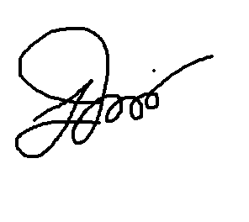

___________________________________
JEREMI D. MARCOS

