CURRICULUM VITAE __________________________________________________________________________________
MARICAR SAYABOC 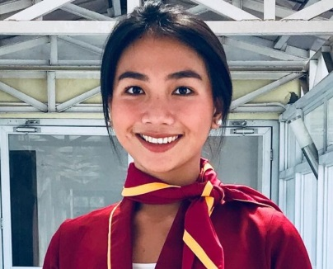
Brgy. Sagayaden Norte, Cabugao, Ilocos Sur
Cell Number: 09052131687
E-mail address: maricarsayaboc240@gmail.com

PERSONAL INFORMATION:

NICKNAME: Maricar
BIRTHDAY: October 18, 1999
BIRTHPLACE: Sagayaden Norte, Cabugao, Ilocos Sur
AGE: 22
NATIONALITY: Filipino
RELIGION: Roman Catholic
CIVIL STATUS: Single
FATHER’S NAME: Judy Toloza
MOTHER’S NAME: Evangeline Sayaboc

EDUCATIONAL BACKGROUND:

TERTIARY: UNIVERSITY OF NORTHERN PHILIPPINES
Bachelor of Science in Tourism Management
Tamag, Vigan City, Ilocos Sur
2018-2022

SECONDARY: ILOCOS SUR COMMUNITY COLLEGE
TECH-VOC
Bantay, Ilocos Sur
2016-2018
San Juan National Highschool
San Juan, Ilocos Sur
2012-2016

ELEMENTARY: PILA ELEMENTARY SCHOOL
Cabugao, Ilocos Sur
2006-2012
EXPERIENCE: Work Immersion
Provincial Tourism Office
80 hrs.
Front office

